# 

 **ngfn**

# 

# OBJECTIVE

The objective of the Analysis is to find the standard behavior of Ankur Warikoo, an influencer, and entrepreneur, for our study. This report delves into an in-depth study of Ankur Warikoo’s posts, during the period from January 1, 2022, to March 31, 2023.   
This study aims to generate insights and theories that could be valuable for aspiring influencers.   
Ankur Warikoo has made a significant impact on the market in the past year; hence his posts serve as the focal point of our research. The research has been done in multiple aspects, including the posting time patterns, content categories, hashtags used and promotional activities are done through them, and other factors also.   
This comprehensive report aims to provide valuable insight into Ankur Warikoo's social media behavior and allow stakeholders to fully understand his strategies and practices as an influencer. By studying Encore Varikoo's behavior and approach, those who wish to pursue a career in this field can gain valuable guidance and insight into how to independently forge a path to success. This report will serve as an invaluable resource for those seeking to understand and navigate the dynamic world of influencer marketing.

**CONTENTS**

1. **Who is Ankur Warikoo?**
2. **Why Choose Ankur?**
3. **Insights:**  
   **3.1. Niche:**  
    3.1.1. Entrepreneurship and business skills  
    3.1.2 Personal development and motivational content  
    3.1.3. Engaged Community and Influencer Metric   
    3.1.4 Collaboration with Brands   
      
   **3.2. Content Category:**   
    3.2.1. Content Category on which Consumers follow their Influencers.   
    3.2.2. The Content Category which has the Best Reaction Rate – The most and   
    least preferred.   
    3.2.3. Top Content Categories posted.  
    3.3.4. Audience Engagement Analysis of Ankur Warikoo’s LinkedIn Posts  
     
   **3.3. Reach and Engagement:**   
    3.3.1. Average number of comments in Ankur's post  
    3.3.2. Total Reaction Posted on LinkedIn [Month and Year Wise]  
    3.3.3. Decoding the ‘Comment’ pattern of Ankur Warikoo  
    3.3.5. Unveiling the Power of Reposting  
    3.3.6. Analysis of Funny Reactions in Ankur Warikoo Posts  
    **3.4. Content Strategy:**  
    3.4.1. Ankur - Man with a Plan !!!  
    3.4.2. Ankur Warikoo’s LinkedIn post that is focused on the Weekdays vs  
    Weekends.  
    3.4.3. Ankur Warikoo's Monthly LinkedIn Post Trends  
    3.4.4 Correlation between the Number of Posts and the Number of Reactions.  
    3.4.5 Hashtag Game (Behind the Scenes)

**4. Impact and Influence**

**6. Conclusion**

**1. WHO IS ANKUR WARIKOO?**

Ankur Warikoo is an Indian entrepreneur and influencer in the digital space, known for his expertise in influencer marketing. With a strong presence on social media platforms and a huge following, Ankur has successfully used his brand to collaborate with brands and promote their products or services. As an entrepreneur and motivational speaker, Ankur Warikoo has mastered the art of connecting with his audience and building a loyal community of followers. His ability to create authentic and engaging content has made him a sought-after influencer for brands looking to tap into his vast network.

Ankur's expertise in influencer marketing goes beyond brand collaboration. He has also shared valuable industry knowledge and insight through workshops, webinars, and speaking engagements. His experiences and learnings serve as a resource for aspiring influencers and brands to effectively navigate the world of influencer marketing.

Ankur Warikoo's influential presence and success in the realm of influencer marketing make him an intriguing subject to examine when examining the impact and effectiveness of his marketing strategy. His ability to authentically connect with his audience and create meaningful brand partnerships sets him apart as a key player in the influencer marketing landscape.

## 

## 

**2. WHY CHOOSE ANKUR?**

Ankur Warikoo is a leading influencer with a focus on entrepreneurship, personal growth, and inspiration. His niche revolves around inspiring and empowering individuals in their professional and personal lives. With a target audience comprising mainly aspiring entrepreneurs, professionals, and individuals seeking personal growth, Ankur has built a strong following on social media platforms.

As an influencer, Ankur Warikoo creates content that combines his personal experiences, practical advice, and motivational stories. He shares valuable insights, strategies, and tips for navigating the startup ecosystem, building successful businesses, and achieving personal growth.

Ankur's content often reflects on resilience, self-confidence, and the importance of accepting failure as a stepping stone to success. He inspires audiences through his journey, sharing stories of overcoming challenges and following his passion.

With its relatable and engaging approach, Ankur has fostered a sense of community among his followers. He actively interacts with his audience, answering their questions and providing guidance, creating a space for meaningful discussions and learning.

Overall, Ankur Warikoo's content as an influencer resonates with individuals seeking inspiration, entrepreneurial insights, and personal growth. His ability to connect with his audience and provide valuable content has established him as a trusted influencer in his niche.

**trend Comparison between the No. of Posts vs. the No. of Reactions against them.**

One of the major factors to become an influencer is choosing the frequency of posts one should have on a monthly basis.   
This is considered the major factors because the frequency the posts are made, reflects directly proportional to the influencer’s consistency on the social media platform he/she is using.

After analysing, comparing only two variables in the insight might not suffice as multiple factors influence the variance of the No. of reactions, and not just the No. of posts.   
This is surely a multivariable equation with a very good chance of containing the ‘e’ factor, but assuming the rest of the variables constant, this analysis has been done.  
  
As it can easily be observed in the case of Ankur Warikoo, that the reach he has gained in the last 1 year, can be said has increased. In the first quarter of the 1.5 year studied, the average no. of post in the 3 months is 56.6 with an average range of 3,14,000 reactions approximately.   
In the second quarter, the average no. of post in the 3 months is 70.6 with an average range of 2,45,000 reactions approximately. In the third quarter, the average no. of post in the 3 months is 85.6 with an average range of 3,67,600 reactions approximately. In the fourth quarter, the average no. of posts in the 3 months is 93 with an average range of 3,50,000 reactions approximately. In the month of April 2022, it can be observed that with an increase of 45% in the No. of posts to 64 leads to an increase in the reaction rate by 22%.   
And, in the month of April 2023, it can be observed that with an decrease of 24% in the No. of posts to 70 from 94, leads to a decrease in the reaction rate by 23%.As it is clearly visible, that the ratio of increase percentage is 2.04:1 and the ratio of percentage decrease is 1.04:1. Concluding the analysis, it can be suggested to any person, that the No. of posts posted in a month has a directly proportional affect on the No. of reactions. With a reduction in the posts, the reaction rate per month reduces at a higher rate and when increase of the posts the reaction rate increase at a slower rate.   
Thus, The person who wishes to move ahead in the path as an influencer, shall most definitely have consistency every month with the No. of posts and increase it always or at least keep it constant so that there is negative affect.

**TOTAL PROMOTION OF HIS/OTHER BRANDS**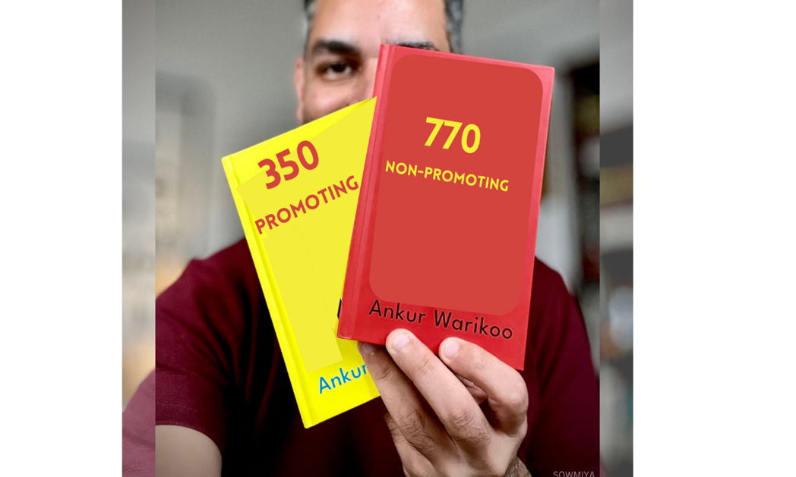

Despite of being an Entrepreneur, Content creator, Teacher and so on. Ankur was a very active member in posting content in LinkedIn, not only just postings and also, he is promoting his/other brands in such a way. In the year 2022-2023, out of 1120 post Ankur’s total count of promoting other brand is 350 and total count of non-promoting is 770. when compared, the percentage of non-promoting post is higher than the promoting post. He promotes the brand in many ways includingimage, textual, video andeven by using hashtag. If we take analyzation on the last one-year brand promotion, using a pie chart, weget the percentage of promoting and non-promoting post.

The detailed analysis of Ankur’s promotion of his/other brands says, In the year 2023 at the month of march the highest promotion of post takes place. Similarly, the second highest promotion takes at the month of September 2022. So, there is a random post promotion of his/other brands.

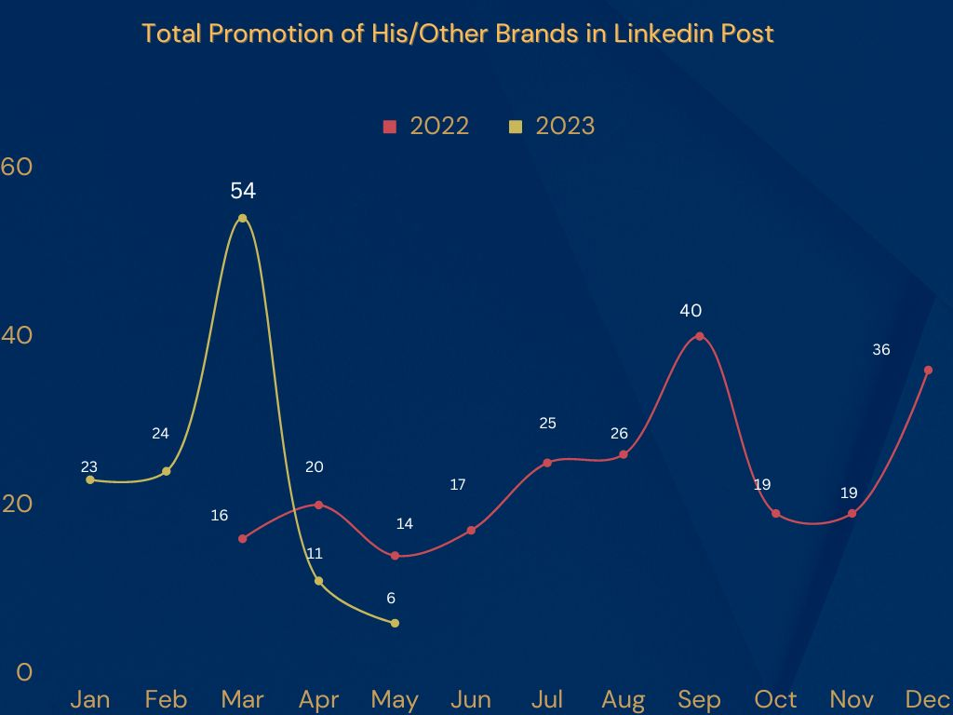

Finally, after my Analysis about Ankur on Promotion of Post, this is the evident that he is also a brand promoter too.

**Audience Engagement Analysis of Ankur Warikoo’s LinkedIn Posts**

One of the most important factors that contribute to the success of an influencer is the timing of the post, or as in the case of this report: the day any sort of content was posted. This helps the content of the influencer reach a wider audience as they happen to be online around the time the influencer posts any content. This report was made with the intention to discover which days of the week do Ankur Warikoo’s posts on LinkedIn tend to get the most engagements over the past 1 year.

Out of a total of **1,53,51,828** Engagements with Ankur Warikoo’s LinkedIn posts over the past 1 year,

**(17.80%)** were on Sunday

**(14.31%)** were on Monday

**(14.91%)** were on Tuesday

**(12.76%)** were on Wednesday

**(14.39%)** were on Thursday

**(09.39%)** were on Friday

**(16.41%)** were on Saturday

As is evident from the above text and the chart, Ankur Warikoo receives the highest Engagement on Sundays **(17.80%)**, a close second being Saturdays **(16.41%)** and the least Engagement he receives is on Fridays **(09.39%)**.

However, in 2023, Saturday emerged as the day when Warikoo’s posts got the most Engagement. The total Engagements on Saturdays is **(19.19%)** and on Sundays, it is **(17.74%).** This is an increase of **(4.31%)** from 2022.

The Conclusion made here is that Ankur Warikoo’s LinkedIn posts get more user engagement on Saturdays and Sundays than on any other day of the week. With this, we can deduce that the demographic of Ankur Warikoo’s LinkedIn audience is more likely to interact with the content of an influencer like Ankur Warikoo on Saturdays and Sundays.

**Influencer present or not present in media**

1. This is the survey of Ankur Warikoo’s absence in media .
2. In the month of October the influencer was least present, while in the month of March the influencer was highly present
3. The average of Ankur Warikoo’s absence in media for the last one year is 46.73

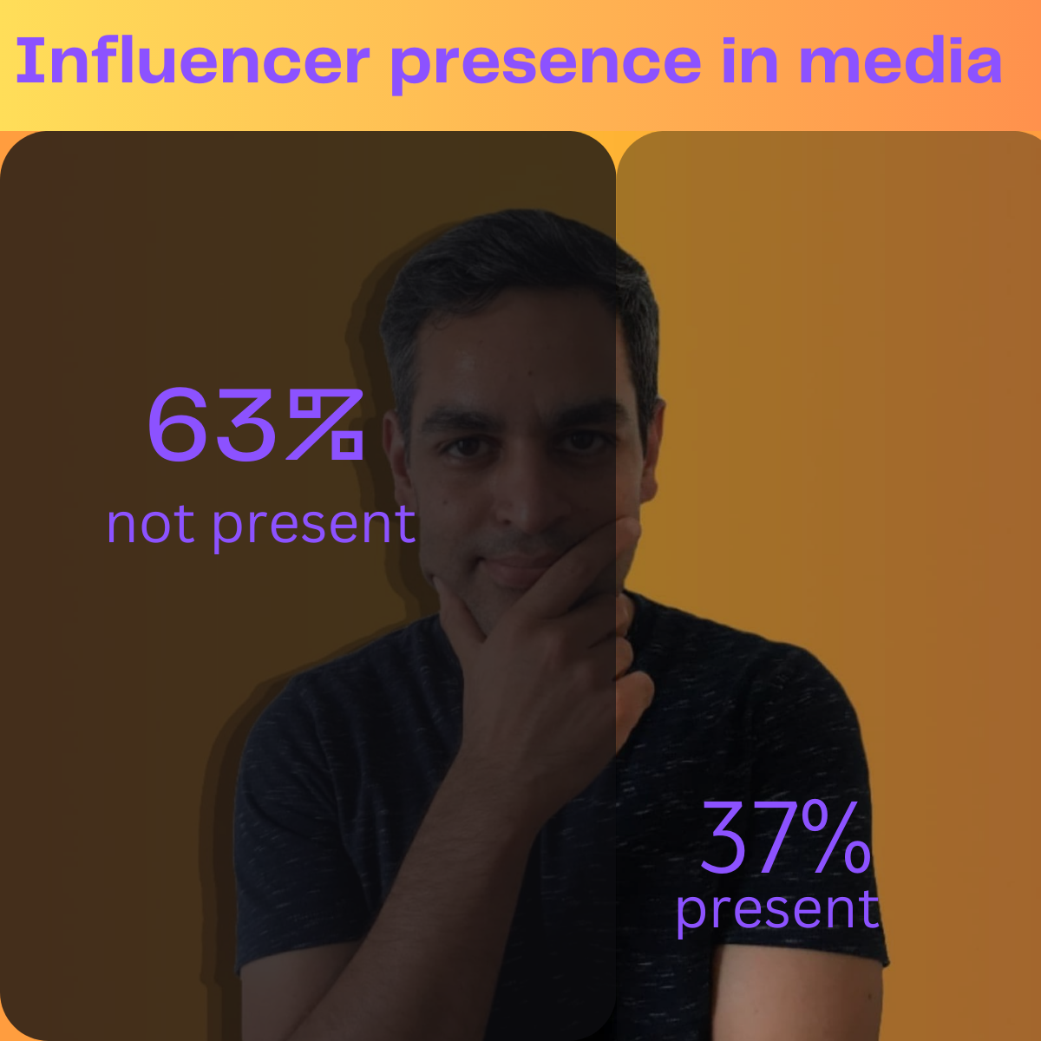**The influencer presence in media is 413 while absence in media is 701 in the last 1 year.**

In only 37% of the post the influencer was present in media. While he was not present in 63% of media in last 1 year.

In November 2022 and march 2023 the influencer is present in media the highest and remains the same further. The lowest month in which the influencer was present in the media is august 2022. The average of Ankur Warikoo’s presence in media in the last one year is 36.62.

CONCLUSION :The above mentioned data explains or shows the Ankur Warikoo’s presence in media (LinkedIn). From the above data we can conclude that, the influencer was 37% present and 63% absent in media. The Influencer was consistent in the media from the month NOVEMBER 2022 to MARCH 2023. In the month of August(2022), the Influencer was only present in 5 medias and was absent in 62 medias.

**Total number of likes on Ankur warikoo’s post on a month-by-month basis over the years**

**DESCRIPTION:**

The table provides a month-by-month breakdown of the total number of likes on Ankur Warikoo's LinkedIn posts over the years.

Here is a detailed description of the data:

**Jan-23:** In January 2023, Ankur Warikoo's LinkedIn post received a total of 297,392 likes. It indicates a considerable level of engagement with his content.

**Feb-23:** In February 2023, the total number of likes on Ankur Warikoo's LinkedIn post increased to 393,247. This represents a significant growth in engagement compared to the previous month.

|  |  |
| --- | --- |
| Month & Year | Total Likes |
| Jan-23 | 297392 |
| Feb-23 | 393247 |
| Mar-23 | 307364 |
| Apr-23 | 230991 |
| May-23 | 151713 |
| May-22 | 271190 |
| Jun-22 | 265910 |
| Jul-22 | 215593 |
| Aug-22 | 187932 |
| Sep-22 | 293388 |
| Oct-22 | 354128 |
| Nov-22 | 341066 |
| Dec-22 | 258507 |

**Mar-23:** March 2023 saw a total of 307,364 likes on Ankur Warikoo's LinkedIn post. Although slightly lower than the previous month, the engagement remains substantial.

**Apr-23:** In April 2023, the number of likes decreased to 230,991. While still a substantial amount, there was a noticeable decline in engagement compared to the earlier months.

**May-23:** The total likes for Ankur Warikoo's LinkedIn post further decreased to 151,713 in May 2023. This represents a significant drop in engagement compared to the previous month.

**May-22:** Although not in chronological order, this entry represents the month of May 2022. In that month, Ankur Warikoo's LinkedIn post received 271,190 likes. This suggests that the engagement level in May 2022 was higher than that in May 2023.

**Jun-22:** June 2022 saw a total of 265,910 likes on Ankur Warikoo's LinkedIn post. The engagement remained relatively stable compared to the previous month.

**Jul-22:** In July 2022, the number of likes decreased to 215,593. This indicates a decline in engagement compared to the previous months.

**Aug-22:** The total likes on Ankur Warikoo's LinkedIn post further decreased to 187,932 in August 2022. This represents a continued decline in engagement.

**Sep-22:** September 2022 saw an increase in engagement, with a total of 293,388 likes on Ankur Warikoo's LinkedIn post. This indicates a recovery in engagement levels compared to the previous months.

**Oct-22:** In October 2022, the engagement continued to grow, with a total of 354,128 likes on Ankur Warikoo's LinkedIn post. This represents a significant increase in engagement compared to the previous month.

**Nov-22:** November 2022 saw a slightly lower number of likes compared to the previous month, with a total of 341,066. Nonetheless, the engagement remains high.

**Dec-22:** In December 2022, the total likes on Ankur Warikoo's LinkedIn post decreased to 258,507. This indicates a decline in engagement compared to the previous months.

**OBSERVATION:**

**Monthly Fluctuations:** There are significant fluctuations in the number of likes on Ankur Warikoo's LinkedIn posts from month to month. The likes vary from a high of 393,247 in February 2023 to a low of 151,713 in May 2023. These fluctuations suggest that the level of engagement with Ankur Warikoo's content can vary greatly over time.

**Growth and Decline:** There are periods of growth and decline in the number of likes. For example, there is a noticeable increase in engagement from May 2022 to October 2022, where the likes almost doubled from 271,190 to 354,128. However, there is also a decline in engagement from October 2022 to December 2022, with the likes decreasing to 258,507. These fluctuations indicate that Ankur Warikoo's posts can experience both periods of increased interest and periods of decreased interest.

**Seasonal Patterns:** The data provided spans multiple years, and there seems to be some seasonal patterns in the engagement levels. For instance, the months from May 2022 to September 2022 generally exhibit higher engagement, with likes ranging from 215,593 to 354,128. On the other hand, the engagement levels seem to decrease towards the end of the year, as seen in the lower likes in December 2022 and the subsequent months of 2023. These seasonal patterns suggest that there may be external factors or trends influencing the engagement with Ankur Warikoo's posts.

**Significant Engagement:** Despite the fluctuations and seasonal variations, Ankur Warikoo consistently receives a substantial number of likes on his LinkedIn posts. The lowest number of likes in the data provided is still 151,713, which indicates a strong level of engagement. This suggests that Ankur Warikoo has a significant following and is able to generate interest and interaction with his content.

**Lack of Complete Data:** It's important to note that the data provided is not comprehensive, as it only includes specific months from different years. Therefore, it may not capture the complete picture of the engagement trends over time. Additional data points would be necessary to draw more accurate conclusions about long-term patterns and overall growth in Ankur Warikoo's LinkedIn post likes.

Overall, the observations highlight the dynamic nature of engagement with Ankur Warikoo's LinkedIn posts, with fluctuations, growth, and seasonal patterns. The data suggests that Ankur Warikoo has a strong following and can generate significant interest in his content, but it also indicates that engagement levels can vary over time.

**CONCLUSION**

Ankur Warikoo's LinkedIn posts demonstrate fluctuations in engagement levels on a month-by-month basis. Despite these variations, Ankur Warikoo consistently garners a substantial number of likes, indicating a strong following and the ability to generate interest and interaction with his content.

**ANKUR WARIKOO INSIGHT POLL**

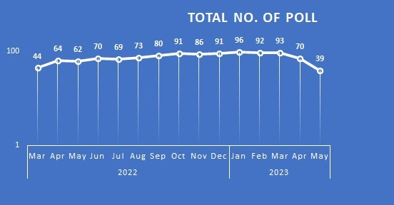

In LinkedIn total no.of Poll ware used 5.74

* (44) were on March
* (64) were on April
* (62) were on May
* (70) were on June
* (69) were on July
* (73) were on Aug
* (80) were on Sep
* (91) were on Oct
* (86) were on Nov
* (91) were on Dec
* (96) were on Jan
* (92) were on Feb
* (93) were on Mar
* (70) were on April
* (39) were on May

**Description-**

Description-Ankur Warikoo, a well-known entrepreneur and business expert, has conducted a significant number of 5.74 polls in just one year. These polls helped him gather people's opinions and make informed decisions.

Ankur understands the importance of using data to make good choices. That's why he actively engaged with his audience and stakeholders by conducting many 5.74 polls. These surveys allowed him to learn what people want and what they think.

Ankur carefully designed each poll, asking relevant and clear questions. By using these polls, he collected a wide range of opinions and insights. This helped him make better decisions and understand different topics more deeply.

Ankur's use of 5.74 polls in a year shows how committed he is to gathering and analyzing data. He believes in using data to guide his actions and serve his audience and community better.

In summary, Ankur Warikoo's use of 5.74 polls in a year demonstrates his strong dedication to understanding people's perspectives. By using these polls, he makes data-driven decisions and strives for excellence in his work.

**Observation**

* -Ankur Warikoo conducted a significant number of 5.74 polls within one year.
* -These polls helped Ankur gather insights and opinions from his audience and stakeholders.
* -Ankur's emphasis on data-driven decision-making is evident through his use of these polls.
* -By actively engaging with his audience through surveys, Ankur shows his commitment to understanding their needs and preferences.
* -The polls allowed Ankur to collect diverse perspectives, enabling him to make informed choices.
* -Ankur's proactive approach to using polls highlights his dedication to obtaining valuable data.
* -The polls served as a valuable tool for Ankur in making informed decisions.

**conclusion-**

Ankur Warikoo used a significant number of 5.74 polls within a year. This shows that he believes in making decisions based on data and understanding what people think. By conducting these polls, Ankur actively involved his audience and gathered valuable insights. This helps him make better choices and serve his audience and community effectively. Ankur's focus on using polls demonstrates his commitment to excellence and staying connected with his audience. Overall, Ankur Warikoo's use of 5.74 polls in a year reflects his strong dedication to data-driven decision-making and making a positive impact in his field.

**Cumulative count of Ankur Warikoo’s Text+Image Posts**

One of the most common types of content categories used by Ankur Warikoo while posting on LinkedIn is an image with text. Out of 1120 posts, 320 were a combination of image and text posts. It seems that Ankur Warikoo wanted to attract his followers by posting more images with text posts. And while posting 30% of this type of content, Ankur didn’t use hashtags. I think there are no relevant hashtags for the post he has posted.

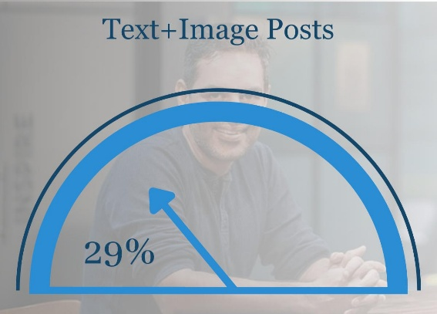In 68% of the posts, Ankur Warikoo was present in the image he posted. This means he wanted to attract his followers by representing himself in the posts so that he could increase engagement. In 7% of these types of posts, Ankur Warikoo is promoting his own brand. This means that Ankur isn’t using more text-and-image posts to promote his own brand; rather, he is just promoting his brand to increase the number of followers. 67% of the posts posted by Ankur Warikoo are scheduled posts. This means that while using this type of content category, Ankur wanted to schedule posts rather than posting directly. And most of the time, ankur Warikoo posted the content in the form of text and images during the weekdays rather than weekends.

Most of the time, Ankur Warikoo isn’t using funny posts in this content category; this is reflected in the funny reactions he got for his posts in this type of content category. And the likes he received for this type of post were more.

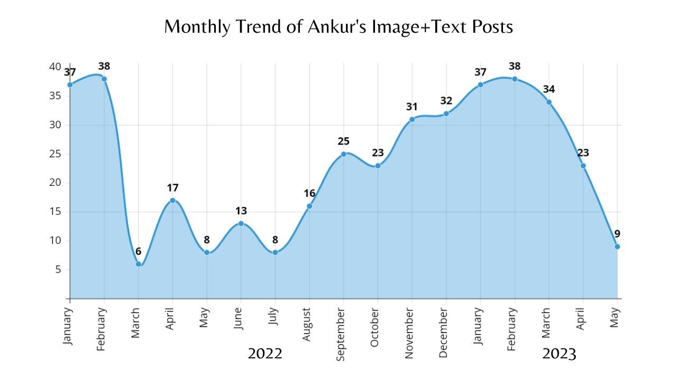As we can see from the trends in text with image posts here, Ankur Warikoo posted more text with image content in the months of February and January of the past year. We can also observe that the number of posts in 2022 and 2023 for the months of February and January are the same. And the very fewest posts are in the month of March in 2022. There were more fluctuations in 2022’s beginning, and the post percentage improved at the end of 2022 until now. This means that more of his followers are likely to see the text-with-image posts of Ankur Warikoo. So, he has improved the post number since the end of 2022.

**Conclusion**: Through the analysis of Ankur Warikoo’s image+text posts on LinkedIn, the valuable insights gained by his social media presence and the potential for audiences to become influencers. The cumulative count of Ankur Warikoo’s image+text posts revealed a consistent and active engagement with the platform, indicating his dedication to sharing valuable content with his audience. By examining the frequency of his posts, Ankur Warikoo maintains a regular posting schedule, which demonstrates his commitment to staying connected with his followers. This consistency in posting can be an important factor for aspiring influencers to consider, as it helps build a dedicated audience base.

Based on the analysis, aspiring influencers can learn valuable lessons from Ankur Warikoo’s LinkedIn presence. Consistency in posting, selecting relevant and appealing visuals, and maintaining a positive and inspiring tone are key factors that contribute to his influence and following. By incorporating these strategies into their own social media approach, individuals can increase their chances of becoming influencers in their respective fields.

I am thrilled to present to you a comprehensive data analysis on Ankur Warikoo's total reactions over the course of a year. Through careful examination and visualization of the data, we have gained valuable insights into Ankur's audience engagement. Let's dive into the findings and stories behind the numbers.

Firstly, let's explore the yearly distribution of Ankur's total reactions using a pie chart.

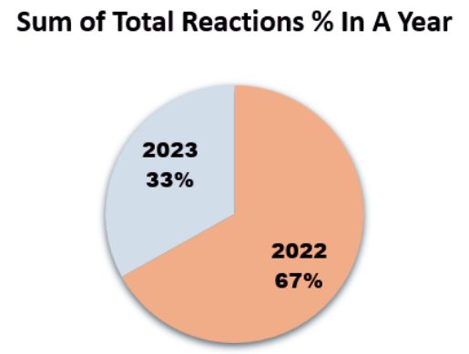

In **2022**, Ankur's content generated an astounding **66.89%** of the total reactions, amounting to an impressive **3,079,870** interactions. This showcases the immense impact Ankur had on his audience during that year. However, in **2023**, the dynamics shifted, with the total reactions accounting for **33.11%** of the grand total, reaching **1,524,422** reactions. This indicates a noteworthy growth in audience engagement during the analyzed period.

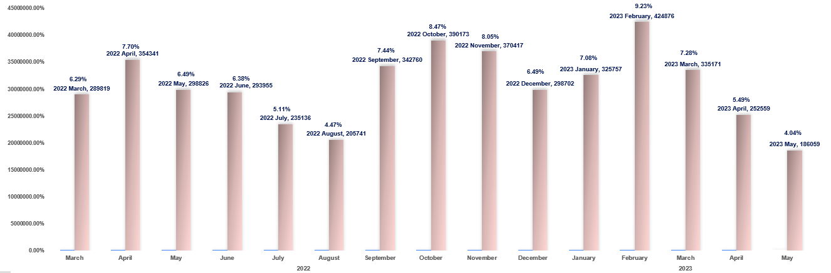

Moving on to the **monthly analysis**, we visualized the data using a **Clustered Column Chart**. The chart provides a clear comparison of the total reactions received each month, allowing us to identify the months with the highest and lowest engagement. In February **2023**, Ankur experienced a significant surge in engagement, amassing a remarkable **9.23%** of the total reactions, equivalent to **424,876** reactions. This month stood out as the peak of audience interaction throughout the analyzed period.

To put these numbers into context, let's delve into a theoretical story based on the data. Ankur Warikoo, a renowned influencer, has been capturing the attention and admiration of his audience. In **2022**, Ankur's captivating content sparked an outpouring of reactions, with his posts generating **66.89%** of the total interactions. This speaks volumes about the resonance of his message and the connection he established with his followers.

As we shift our focus to the year **2023**, we witness a surge in engagement, with Ankur's content capturing **33.11%** of the total reactions. This growth demonstrates Ankur's ability to continuously captivate and inspire his audience, leading to a wider reach and deeper engagement.

Analyzing the monthly trends, we discovered that Ankur's content achieved varying levels of engagement throughout the year. February **2023** emerged as a standout month, garnering **9.23%** of the total reactions. This exceptional performance is a testament to Ankur's ability to produce content that resonates deeply with his audience, igniting their interest and sparking meaningful conversations.

In conclusion, Ankur Warikoo's total reactions provide us with valuable insights into his audience's engagement patterns. The combination of the yearly pie chart and the monthly clustered column chart allows us to visualize the ebb and flow of reactions, highlighting the months of peak engagement. Through this data analysis, we can appreciate Ankur's impact as an influencer and recognize the power of his content in connecting with and inspiring his audience.

I hope you found this data analysis on Ankur Warikoo's total reactions both informative and insightful.

**Decoding the ‘Comment’ pattern of Ankur Warikoo**

The following report analyzes the changes observed in the ‘Comment’ section of Ankur Warikoo's LinkedIn posting strategy. The focus is on highlighting the impact of this shift on audience engagement and interaction. By examining the data and trends, we aim to gain insights into Ankur's evolving approach and its implications on his LinkedIn presence.

Insight 1: Over the course of a year, Ankur Warikoo's posts displayed remarkable engagement

* Out of 1,120 posts, he amassed a staggering total of 141,850 comments, showcasing a solid level of interaction and interest from his audience.
* 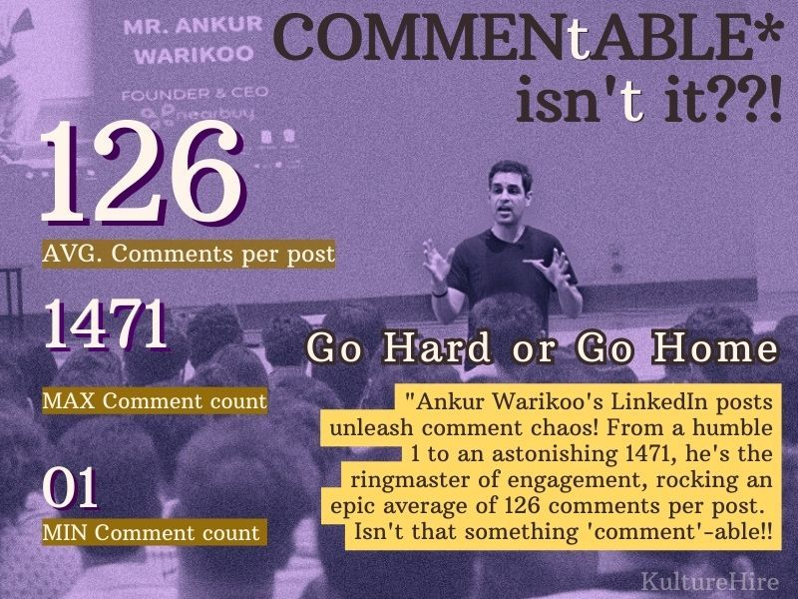The maximum number of comments received on a single post skyrocketed to an impressive 1,471, demonstrating the extraordinary engagement his content can generate.
* On the other end of the spectrum, the minimum number of comments on a post was only 1, highlighting the natural variation in engagement levels.

Insight 2: The trend chart for the period from March 2022 to May 2023 revealed fluctuations in the average comments per month:

* The highest average comments per month, peaking at 173, was recorded in April 2022. This indicates a month of particularly high engagement and audience interaction.
* In contrast, the lowest average comments per month dropped to 93 in August 2022, suggesting a comparatively quieter period in terms of audience engagement.

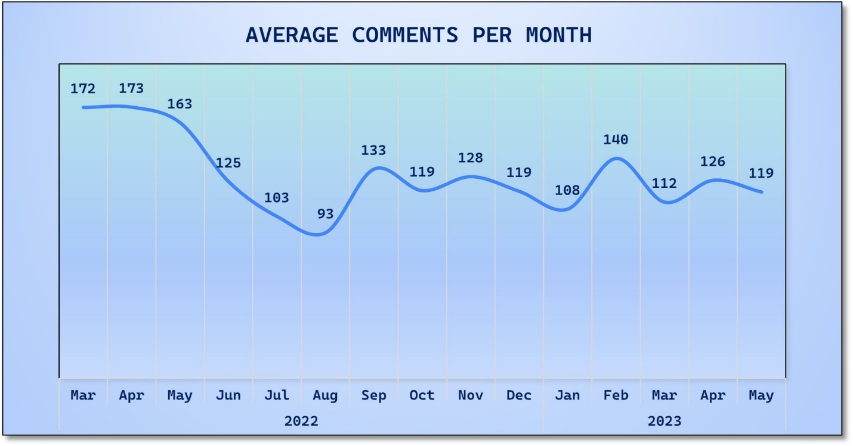

These insights demonstrate Ankur Warikoo's ability to captivate and spark discussions among his LinkedIn followers. The high total comment count, accompanied by significant variations in average comments per month, indicates his consistent ability to generate interest and active participation in his posts.

From Studying various other insights available in this report we found out:

Insight: In 2022, Ankur Warikoo's posting strategy on LinkedIn underwent notable changes

* At the beginning of the year, Ankur predominantly shared text-based posts, engaging directly with his audience through written content.
* However, as the year progressed, there was a significant decline in the frequency of text posts authored by Ankur.
* Simultaneously, there was a noticeable surge in the utilization of other content categories, indicating a shift in Ankur's posting approach.

This shift suggests that Ankur Warikoo diversified his content strategy over time, exploring alternative formats to engage his LinkedIn followers. While text posts were prominent initially, there was a deliberate move towards utilizing different types of content to deliver his messages and capture the audience's attention.

Further analysis and exploration could be done to understand the specific content categories that gained traction, such as images, videos, articles, or other forms of media, as this can provide insights into Ankur's evolving content strategy throughout the year.

**Unveiling the Power of Reposting: Insights into Ankur Warikoo's Engaging Content Categories on LinkedIn**

**Introduction:**

In this comprehensive analysis report on Ankur Warikoo's LinkedIn posts, we delved into the vast amount of data available to gain valuable insights into the repost patterns based on content categories. By examining the engagement and repost metrics, we aimed to uncover the types of content that reposted most with Ankur's audience, shedding light on the preferences and interests of his followers.

Ankur has not only amassed a large following but has also witnessed an astounding number of reposts, providing valuable insights into the impact of his posts. One noteworthy milestone was reached in October 2022 when his posts garnered a staggering 9,030 reposts, a remarkable feat that highlights the profound resonance of his ideas.

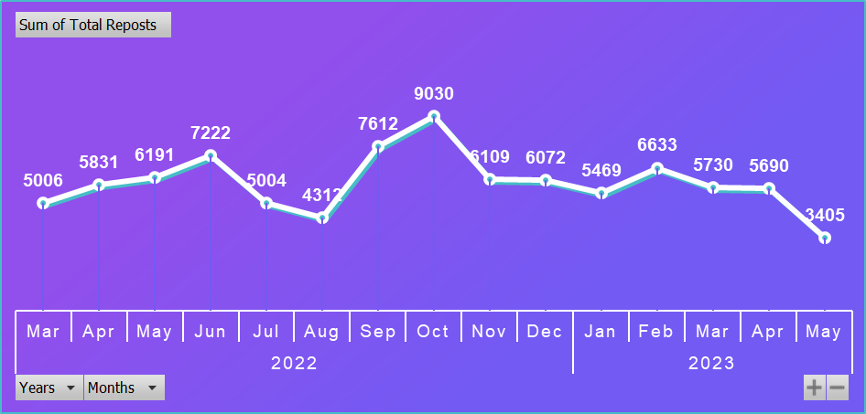

Maximum Number of Reposting

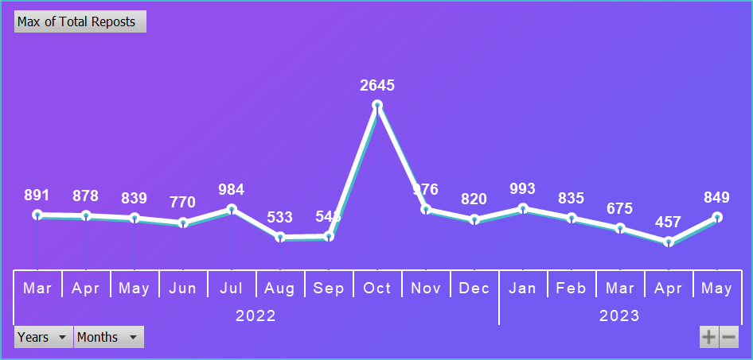In October 2022, Ankur Warikoo, a beacon of wisdom and inspiration, shared a remarkable piece of content on LinkedIn that sparked an unprecedented wave of engagement. With a staggering maximum number of 2645 reposts, this thought-provoking post captured the essence of Ankur's mission to empower individuals and foster genuine connections in the digital age.

Insights of Total Reposting with content categories

In analyzing the data presented in this column chart, we can derive meaningful insights regarding the most reposted content categories. Surprisingly, the category that garnered the highest number of reposts from people over the course of a year was "Carousel," which reached an astounding 27,972 reposts in percentage is roughly around 32%. This figure alone showcases the immense popularity and appeal of this content type.

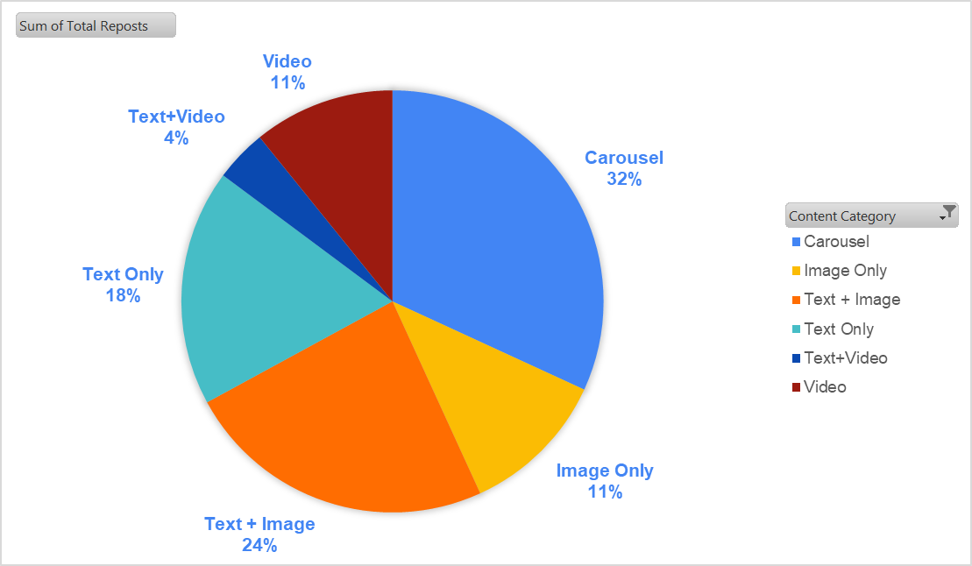

Following closely behind, we have the "Text+Image" category, which accumulated a significant 20,971 reposts in percentage roughly around 24%. This demonstrates the strong engagement and interest of users in this particular combination of textual and visual elements.

The third most reposted category is "Text" only, which garnered a noteworthy 15,910 reposts in percentage roughly around 18%. Although lacking the additional visual component, it is clear that textual content continues to capture the attention and encourage sharing among users.

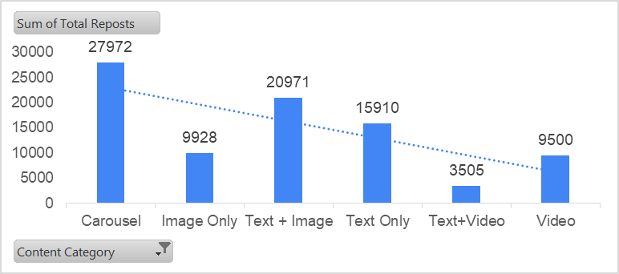

The "Image" category secured the fourth position with over 9,928 reposts in percentage roughly around 11%, further highlighting the influence and impact of visually captivating content on user engagement.

Next in line is the "Video" category, which amassed a respectable number of reposts, although specifically, 9500 reposts in percentage are roughly around 11%. This suggests that videos, while popular, may not have generated the same level of sharing as the aforementioned categories.

Lastly, we have the "Text+Video" category, which received a comparatively lower number of reposts, specifically 3,505 in percentage is roughly around 4%. This implies that while the combination of text and video elements holds some appeal, it did not repost as strongly with users as the other content categories.

Overall, this analysis sheds light on the varying degrees of user engagement and sharing tendencies across different content categories, underscoring the importance of understanding audience preferences and tailoring content strategies accordingly.

**Conclusion:**

In this comprehensive analysis of Ankur Warikoo's LinkedIn posts, we discovered valuable insights into the repost patterns and content preferences of his audience. With an astounding number of reposts, Ankur's posts demonstrate his ability to be reposted by followers. "Carousel" emerged as the most reposted category, followed closely by "Text+Image," showcasing the power of engaging visuals. The "Text" category also garnered significant attention, emphasizing the impact of impactful written content. Visually captivating "Image" posts and videos were popular, although to a slightly lesser extent. Understanding these preferences enables Ankur to tailor his content strategy and foster genuine connections with his audience.

**Analysis of Funny Reactions in Ankur Warikoo posts**

In December 2022, Ankur Warikoo's posts

received a remarkable number of funny

reactions, totalling 11,897. This accounts for a

significant portion of the overall funny

reactions recorded in the past year, which

amounted to 41,426. It is noteworthy that a

majority of the posts in December 2022

were categorized as image content, and these

posts garnered 8,061 funny reactions. Upon

analysing Ankur Warikoo's posts over the past

year, it becomes evident that the image

category has been particularly successful in

generating a plethora of humorous reactions.

In fact, a substantial 55% of all the funny

reactions in the total pool were recorded in

2022.This serves as a testament to the

engaging and entertaining nature of Ankur

Warikoo's image-based content throughout the

 year. In December 2022, Ankur Warikoo's

posts garnered a significant level of

engagement in the form of funny reactions.

These reactions accounted for 29% of the

total engagement, which includes reactions,

reposts, and comments combined. This

indicates a strong resonance with the

audience, as they found Ankur Warikoo's

content particularly amusing during that month.

It's worth noting that the high percentage of

funny reactions in December 2022

demonstrates the effectiveness of Ankur Warikoo's posts in eliciting a positive and

humorous response from his audience. This level of engagement highlights the appeal and

entertainment value of his content, contributing to the overall success of his online

presence.

**Conclusion:** Overall, the data supports the notion that Ankur Warikoo's online presence

thrived in 2022, with a significant emphasis on humour and entertaining content,

particularly within the image category. This success is a testament to his ability to engage

his audience and create an enjoyable and engaging online experience. Furthermore, the

level of engagement, specifically in terms of funny reactions, indicates the positive

response from Ankur Warikoo's audience during December 2022. This highlights the

effectiveness of his posts in evoking amusement and capturing the attention of his

followers. the data analysis of Ankur Warikoo's posts reveals a notable trend in December

2022, where a significant number of funny reactions were recorded. These reactions

accounted for a substantial portion of the overall funny reactions observed throughout the

year, emphasizing the humour and entertainment value of Ankur Warikoo's content.

Moreover, the image category proved to be particularly successful in generating humorous

reactions, as evidenced by the high number of funny reactions received by image-based

posts in December 2022. This further underscores the engaging nature of Ankur Warikoo's

content and its ability to resonate with his audience.

**Celebration Reactions of Ankur Warikoo’s Post**

**Introduction:**

This report presents an analysis of the trend in total celebration reactions received for Ankur warikoo posts on LinkedIn. The data covers the period from 2022 to 2023, providing insights into the engagement levels and identifying notable trends

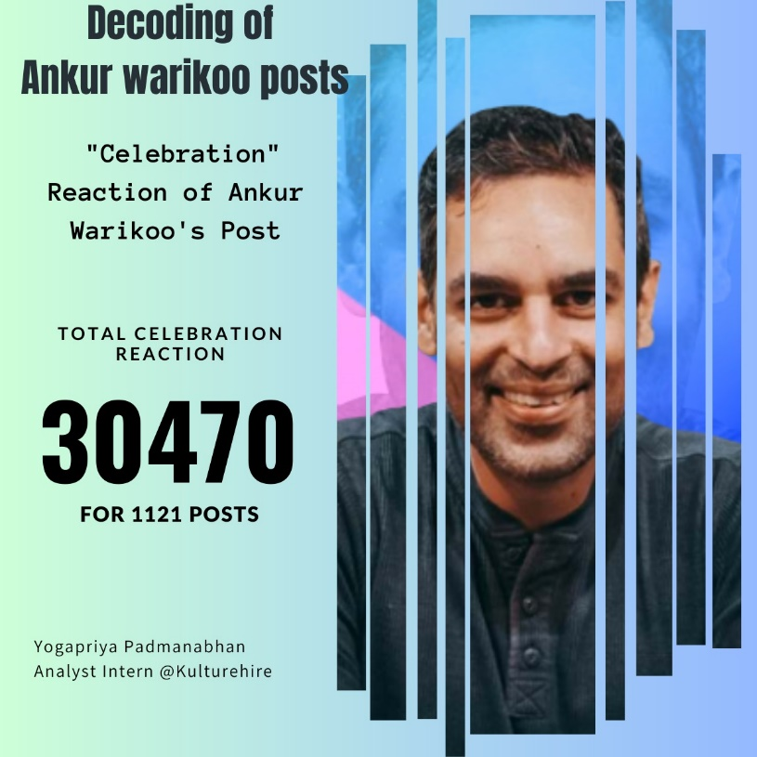

The highest number of total celebration reactions received in 2022 was 488, which occurred in both September and December.

In 2022, the total celebration reactions received varied throughout the year, with the lowest count being 121 in June.

The trend continued into 2023, where the Ankur warikoo received the highest number of total celebration reactions in January, with 502 reactions.

The total celebration reactions for the Ankur warikoo posts in 2023 varied from month to month, with a decrease in February (263 reactions) and March (120 reactions), followed by an increase in April (384 reactions) and May (417 reactions).

**Insights**:

* The engagement levels displayed fluctuations from month to month, indicating a degree of variability in the Ankur warikoo content or external factors impacting audience response
* The Ankur warikoo posts received varying levels of engagement throughout the analyzed period
* The lowest engagement was recorded in June with only 121 reactions. This could indicate a relatively quieter period or posts that didn't generate as much interest.
* Ankur warikoo experienced notable peaks in engagement during September and December of 2022, as well as in January of 2023. These months saw the highest total celebration reactions, indicating that Ankur warikoo content resonated strongly with the audience during these periods.
* The engagement levels fluctuated throughout the year, with varying counts of total celebration reactions each month

**Conclusion:**

Based on the analysis of the provided data, the Ankur Warikoo's posts on LinkedIn demonstrated fluctuations in the total celebration reactions received. Notable highlights include the high engagement levels in September and December of 2022, as well as January of 2023. However, it is important to note that there was some variability in engagement from month to month, with both increases and decreases observed.

**Decoding the “ AM vs PM ” Active post of Ankur Warikoo !!**

I am very excited to present you the data analysis of Ankur Warikoo’s most active post over the year (am vs pm). Through carefully examination and visualization of the data, we have gained valuable insights into Ankur’s active post strategy. Let’s dive into the findings and stories behind the numbers.

Firstly, let’s explore the Active AM vs PM post over the course of the year, Ankur Warikoo’s posts displayed remarkable engagement.

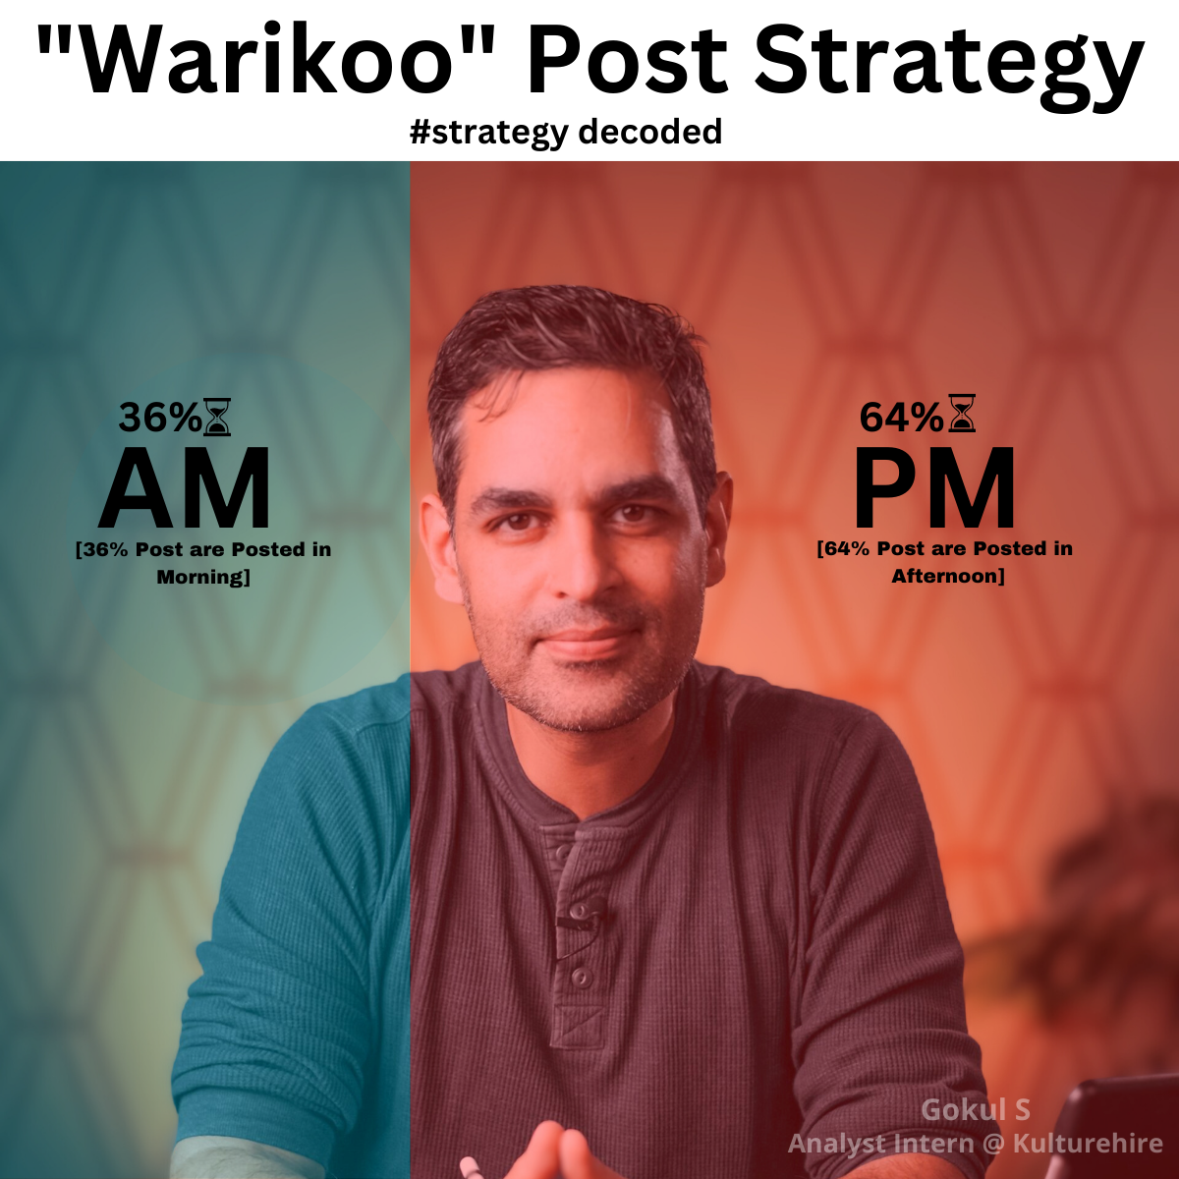

Insights 1 :

* Out of 1,120 posts, 403 posts are posted in Afternoon(PM) and 717 posts are posted in Morning(AM).
* The maximum number of posts are in Afternoon in the last one year. This tells he is way more active in the second half.
* This strategy will help him in get more audience engagement, more followers and give growth in his Linkedin.
* On the other side, 36% the Morning posts are also get decent engagement. Afternoon posts (64%) are high when compared to Morning posts are low.

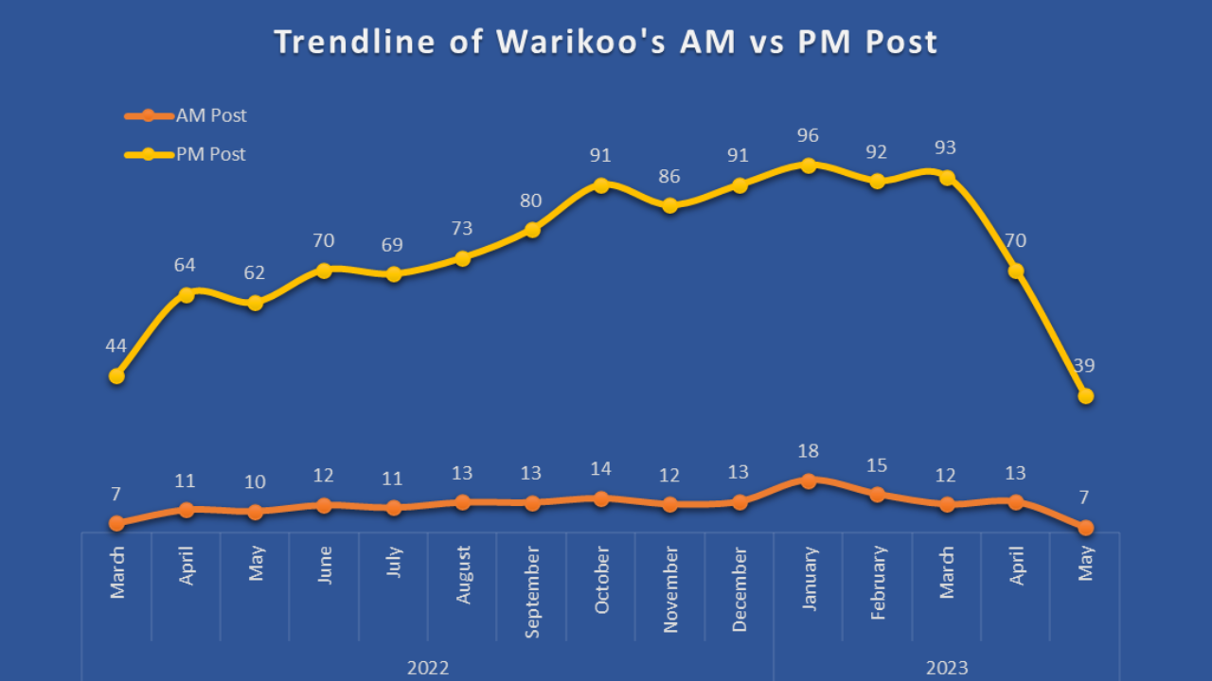

Insights 2 :

* This Trend chart for the period from March 2022 to May 2023, it will reveal the fluctuations of post for every month.
* In march, the AM post was low (7) and the PM post was high (44). This is the strategy he followed the whole 1 year.
* His most of the Morning post was between 7 to 18 posts and the Afternoon post was between 39 to 96 posts.
* Analyzing this monthly trend, we discovered that Ankur’s post achieved varying levels of engagement throughout the year. In Jan 2023, he posted 114 post. This is the highest post he posted when compared to other month.

In conclusion, Ankur warikoo’s total post provides us valuable insights and Active post strategy. The combination of Post and Trend chart will allow us to visualize the Higher active post(AM vs PM) and Highlighting the month of peak post. Through this analysis, we can appreciate Ankur Warikoo impact as a influencer, inspiring his audiences and a growth hacker. I think the above analysis of Ankur Warikoo active post strategy was informative and insightful to you.

**“Most Engaged Quarters of Ankur Warikoo”**

The following analysis deals with Most Engaging Quarter of Ankur Warikoo’s Linked in post for the past one year and also going to focus on trends where Ankur Warikoo getting his most Likes, Comments and Reposts. By collecting the data from his post, this analysis will give some Insights about How Ankur Warikoo Became an Influencer in Linked In.

**First Quarter of a Year 2023 Is the Most Engaging Part of Ankur Warikoo**

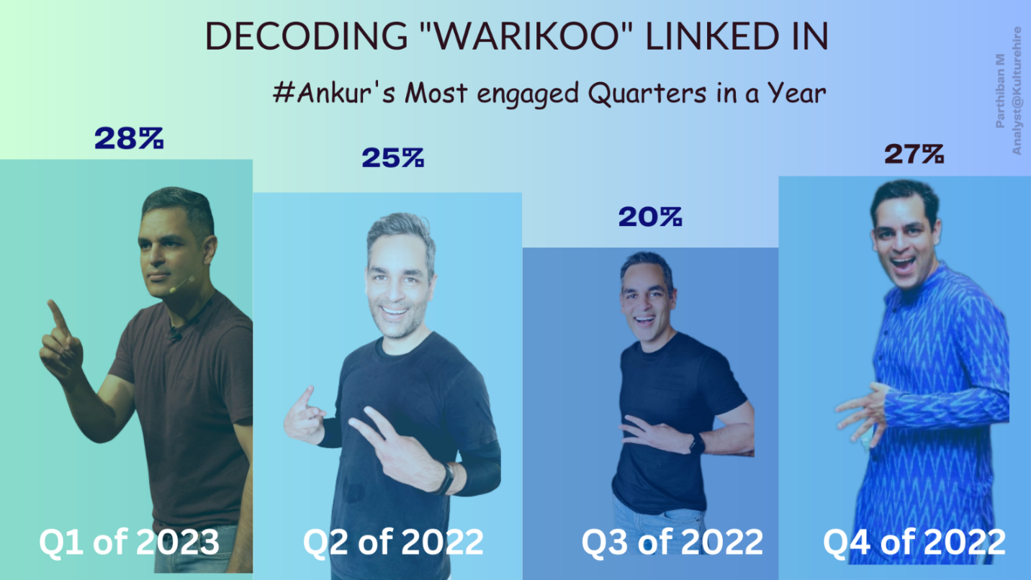

* As per the analysis from the collected data the total engagement he gained in the Past one year is **40,71,884** it clearly shows that he was a popular among his followers in Linked In.
* On 13 Nov 2022 he got the greatest number of engagement **59,769** and that is motivational post which is posted in his favorite timing 8.30 am which clearly shows this post is a Scheduled post.
* On 16 Nov 2022 he got least number of engagement 53 and this reshared post In this he talks about his book Get Epic Shit Done and posted it at 11.46 am and this is not a scheduled post.
* The Most Engagement that he is getting on Sunday’s and least on Friday’s as per analysis we done, this shows that his followers were engaging him mostly in his weekend posts.
* In this we have concluded that Quarter 1 of 2023 Part is the most engaging part Of Ankur warikoo’s post which occupies **28%** in the past one year.

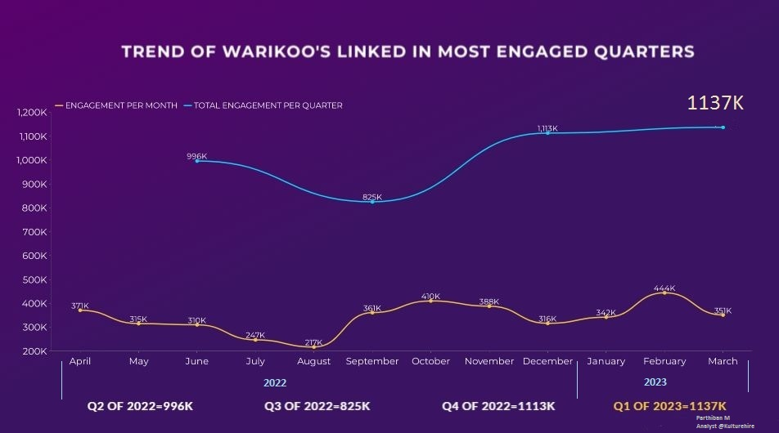

* This Line Graphical analysis shows that in First Quarter of 2023 Ankur Warikoo gained 1137K engagements which is more than the other quarters
* The Most Engagement that he was getting in February Month of 2023 and least engagements in the month of August 2022
* The graphs Shows that Engagements gradually falls from April 2022 to August 2022 and its getting hiked in September 2022.

Here by this analysis, we are concluding that Quarter 1 of 2023 is the Most Engaging Quarters of Ankur Warikoo, He was getting most number Engagement when he was posting Images With text and getting least number of engagement when he shares the other post.

**Hashtag Game (Behind the scene)**

This report provides a detailed analysis of the top 20 hashtags used by Ankur Warikoo on linkedIn between Mar’22 to May’23. By examining the frequency and themes of these hashtags, we gain insights into the Ankur Warikoo's focus areas and the content he offers to their audience.

* The hashtag "#warikoo" has been used the most, with a count of 648. This suggests that Ankur Warikoo, is likely associated with this hashtag and it represents a significant aspect of his content or online presence.
* There are some hashtags that have been used only once, suggesting either a less frequent occurrence or possibly representing specific events or topics that were briefly mentioned.
* Hashtags related to personal development, motivation, and self-improvement, such as "#awareness," "#success," and "#life," have been used frequently. This indicates Ankur's focus on sharing insights and advice on these topics.
* Hashtags like "#job," "#career," and "#work" are also quite prevalent, with relatively high usage counts. This suggests Ankur's involvement in discussions or content related to professional life, employment, and career growth.
* Other notable hashtags include "#leadership," "#productivity," "#team," and "#failure," which indicate Ankur's interest in leadership, productivity, teamwork, and embracing failure as a part of personal and professional growth.Top of Form

[**Most**](https://1drv.ms/w/s!AD326QjfZoN4gVE) **Engaging Content Category of Ankur Warikoo on LinkedIn over last 1 year.**

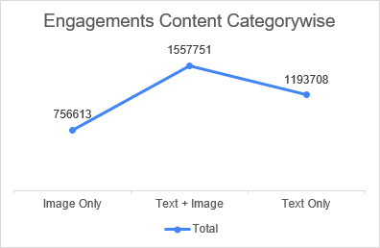Mr. Warikoo’s consumers find **(Text + Image)** to be the most engaging content category with **32.33%** engagement of all the engagements. The second most engaging content category that consumers of Warikoo find is when he posts something which includes **Text** **only** with **24.78%** of all the engagements**.** The Third most engaging content category for Warikoo’s audience is content that has **only** **Image** in it with **15.70%** of engagements.

**Text+ Image: -** Ankur posted 322 posts out of which there were **68.32%** posts in which the Influencer was present and in **39.44%** posts he was promoting his or others brand. So, from here it is clear that his favorite content category for doing promotions is Text + Image. He also knows how to promote himself and increase his face value by posting content in which he is present, that is why he uses his own pic most of the time while promoting

**Text + Image**

**Text**

**Image**

**32.33%**

**24.78%**

**15.70%**

**Top 3 Content Engaging category**

Overall engagement for **Text + Image** is **(15,57,751)** which is **30%** higher than the second most engaged category which is **Text only** with **(11,93,708)** engagements. However, the third most engaged content category **Image only**, got only **(7,56,613)** engagements.

**Observation**: - Ankur mostly uses Scheduled post for these 3 Content Category, he has posted 322 posts under **(Text +** **Image)** and out of which 160 were Scheduled posts which is **50%** approx. While posting under the category of **Texts only**, out of 340 posts 239 posts were Scheduled posts which is **70.29%**. When his content is about **Image only** with any text then out of 89 posts 66 posts were Scheduled posts which is **74.15%**

**Conclusion**: - Ankur gets most of the engagements in his post when his content category is **(Text + Image)** that is why his most of the posts falls under this category with **32.33%** of his overall postings. In this way he tries to keep his audience engaged with him and he has been successful in that. So, it can be said that people find it more engaging when content has Text along with Image. So, those who are trying to become Influencers, they should keep this in mind and should post more content with **(Text + Image).**

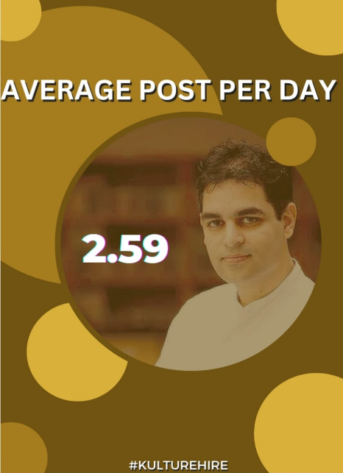**Count of Post vs Average of Total Reactions**

The average number of posts per day is approximately 2.6, which can be rounded to 3. However, starting from January 2023, there has been a decrease in the number of posts. Despite the decline in posts, there has been an increase in the overall reactions received.

**Description:**

However, starting from January 2023, there has been a decrease in the number of posts. Despite the decline in posts, there has been an increase in the overall reactions received. It is worth noting that there is a positive correlation between the count of posts and the average of reactions.

Upon analyzing the data, it becomes evident that the decrease in the number of posts has not hindered the overall engagement levels. On the contrary, it appears that the quality and impact of each post have improved. This observation suggests that the content being shared is resonating more strongly with the audience, leading to increased reactions. The decrease in post frequency may have allowed for more thoughtful and strategic content creation, resulting in higher quality posts that generate more significant reactions.

**Correlation between sum of total reaction and count of post**

The positive correlation between post count and reaction sum suggests that consistent posting still plays a role in driving engagement. Although the number of posts has decreased, it is important to maintain a regular schedule to keep the audience engaged and maintain a connection with them. Consistency in posting helps build familiarity and expectations among the audience, and when coupled with impactful content, can result in a higher sum of reactions.

However, it is essential to note that the correlation between post count and reaction sum, while positive, does not imply causation. Other factors, such as the relevance and quality of the content, the timing of the posts, and the audience's preferences, may also contribute to the increased reactions. It is crucial to continue monitoring and analyzing these factors to gain a deeper understanding of the relationship between post count and engagement levels.

It is worth noting that there is a positive correlation between the count of posts and the sum of reactions. If we see the value vary from (62 -96) in Post, While in reaction its vary from (298k – 325k)  
This trend suggests that even with fewer posts, the engagement and impact of each post have improved. It could indicate that the content being shared is resonating more strongly with the audience, leading to increased reactions. The decrease in post frequency may have allowed for more thoughtful and strategic content creation, resulting in higher quality posts that generate more significant reactions.  
The increased reactions could be attributed to several factors. Firstly, the decrease in the number of posts might have led to a sense of anticipation among the audience, making each post more impactful.

**Conclusion:**

Despite a decrease in the number of daily posts, the engagement levels have improved, as indicated by the increased reactions. This observation highlights the importance of both quality and consistency in content creation. By focusing on creating impactful posts and maintaining a regular posting schedule, it is possible to maximize engagement and strengthen the connection with the audience. However, it is also essential to consider other factors that may influence engagement, such as content relevance and audience preferences. Continual analysis and adaptation based on these insights will help optimize future content strategies and further enhance engagement levels.

**Top content categories posted on linkedin:**

Ankur Warikoo is known for his preference to showcase his content, views, and thoughts on LinkedIn through informative text accompanied by images. This combination allows him to effectively communicate his ideas and engage with his audience. By using text, Ankur can provide detailed explanations, insights, and actionable advice, while images serve as visual aids to enhance the understanding and impact of his messages.

In addition to standalone posts, Ankur also utilizes carousel posts on LinkedIn. Carousels enable him to share a series of related thoughts or ideas in a single post, allowing for a more comprehensive and cohesive narrative. This format enables Ankur to dive deeper into a topic, provide step-by-step guidance, or present multiple perspectives on a subject. Carousels are particularly effective in capturing and maintaining the attention of his audience, as they encourage scrolling and interaction.

By leveraging text, images, and carousel posts, Ankur Warikoo maximizes the impact of his content on LinkedIn. This multifaceted approach enables him to effectively convey his thoughts, deliver valuable information, and engage with his audience in a visually compelling and informative manner. Through this strategy, Ankur can spark meaningful conversations, inspire others, and share his expertise and experiences with professionals seeking knowledge and growth in their respective fields. We can clearly understand the statistical aspects of Ankur’s posts in which he uses all three categories of posts

**Observations-**

* As we can see in above graphs that Ankur posts has highest no of posts which consists of text along with the image in consecutive 4 months from January till April
* From May to October his posts mainly consists of text only which enables him to provide detailed explanations, insights, and actionable advice
* By the year end his posts again has a balanced combination of texts and images along with it which shares his expertise and experiences, providing valuable information to professionals
* We can also have an observation from the pattern of his posts that he uses a pattern of text or text along with image which makes his multifaceted approach maximizing the impact of his content on LinkedIn, sparking meaningful conversations and inspiring others.
* Carousals are also used in his post in significant numbers to attract more users to gain more viewership’s and media engagement in order to seek more support and attention.
* We can also notice a longitudional wave pattern in the graph as well which clearly justifies the consistency and repetition of the pattern of posts which is playing one of the most important reasons of his success in content creation and high viewership

**Conclusions-**

* Ankur warikoo prefers to showcase his content, views, and thoughts on LinkedIn through informative text accompanied by images.
* This combination allows him to effectively communicate his ideas and engage with his audience.
* Text enables him to provide detailed explanations, insights, and actionable advice, while images serve as visual aids to enhance understanding and impact.
* Ankur utilizes carousel posts on LinkedIn to share a series of related thoughts or ideas in a single post, providing a comprehensive and cohesive narrative.
* Carousels allow for deeper exploration, step-by-step guidance, or presenting multiple perspectives on a subject.
* Carousels are effective in capturing and maintaining audience attention, as they encourage scrolling and interaction.
* Ankur's multifaceted approach maximizes the impact of his content on LinkedIn, sparking meaningful conversations and inspiring others.
* Through his content strategy, Ankur shares his expertise and experiences, providing valuable information to professionals seeking knowledge and growth in their respective fields.

**Reaction of media posts based on the presence of Mr. Ankur Warikoo.**

The presence of Mr. Ankur Warikoo in his media content is of significant importance for several reasons:

* The inclusion of an influencer in their media material enables them to engage their audience more personally. The influencer might be perceived as relatable by viewers and followers.
* Influencers are known for their distinctive personalities and perspectives and are frequently followed. Presence of Mr. Ankur Warikoo in his media content help the audience connect with them more deeply and gain a greater understanding of their values, interests, and area of expertise through frequently featuring in his media material.
* Mr. Ankur Warikoo is frequently followed because of his unique personality and viewpoints. By constantly appearing in his media content, he enables his audience to better relate to them and comprehend their values, hobbies, and area of expertise.

**Media Types**

Mr. Ankur Warikoo publishes his media content in 4 categories. They are

* Image Only
* Text + Image
* Text + Video
* Video

**Presence of Mr. Ankur Warikoo in Media**

Mr. Ankur Warikoo has been present in more than 65% of the media postings he has made in the last year, or about 2/3 of all of his media posts, including images and videos.

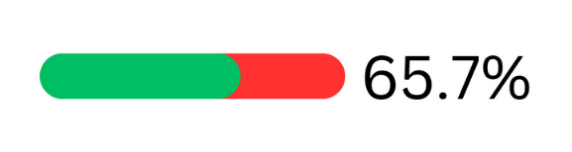

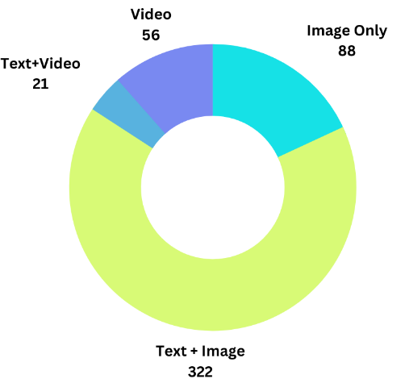**Media Content Category**

Text + Image makes up more than 66 percent of the overall media material, making it his preferred media type.

Even though there are fewer Image only posts than Text + Image posts, the average engagement for Image only posts is higher than the other ones, leading to a reach gain of 45 percent more engagements.

The prominence of visual components in influencer content creation is indicated by the inclusion of the "Image Only" and "Text + Image" categories, both of which have a sizable number of entries. Visuals are essential for grabbing the audience's attention, communicating ideas, and increasing engagement.

**Post Reaction**

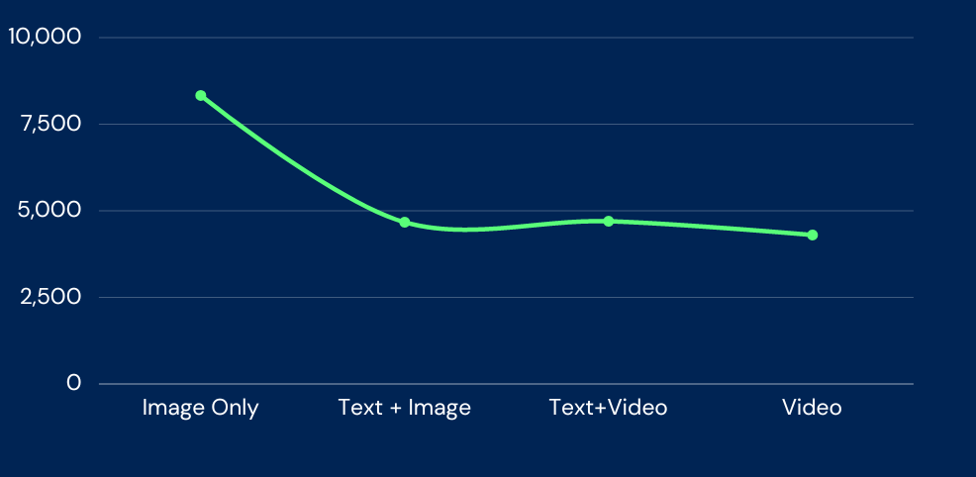

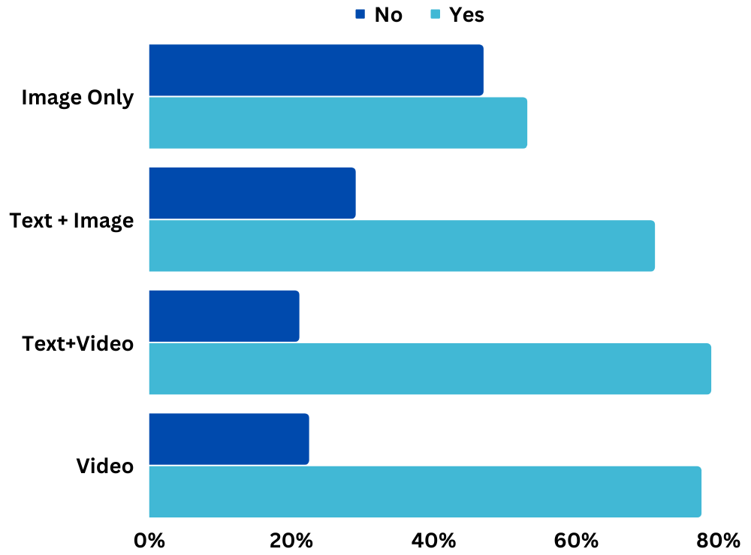When the overall number of reactions to the post is taken into account, Mr. Ankur Warikoo's presence unquestionably enhances the number of reactions above the case where he is absent.While Mr. Ankur Warikoo's presence has little effect on picture media types, it has a significant impact on the post's overall response rate in video media.The post obtains staggering 60 percent more total reactions if Mr. Ankur is in the video. Mr. Ankur Warikoo appears in the media the most on Mondays roughly 52% of the posts, while on the other days, the most he appears in the media is around 39% on Tuesdays.

**Conclusion**

These data suggest that visual and interactive content formats, such as text with images or videos, are frequently given preference by Mr. Ankur Warikoo. Content may be made more intriguing and engaging by combining text and visual elements, which is in line with his objective of creating real relationships with their audience. While the average total reactions for "Text + Image" and "Text + Video" are lower compared to "Image Only", they still indicate a considerable level of engagement. This implies that well-crafted textual content, when combined with images or videos, can still generate meaningful interactions and reactions from the audience. The "Image Only" content type's continuously high average total reactions imply that visual content is very important for engaging viewers and grabbing their attention. Including aesthetically appealing aspects in content appears to have a beneficial effect on the audience's overall response. The higher percentage of Mr. Ankur Warikoo's presence in the "Text + Image" and "Video" content types suggests that he recognizes the value of personal presence in engaging his audience. It allows him to connect more directly with his followers and add authenticity to their content.

**Carousel’s Used by Ankur Warikoo – Decoding influencer’s post**

Carousel :-Carousel is a new format that allows you to add multiple images and/or videos in a single post to create a visually engaging experience for your audience. Carousels are more interactive because users spend more time looking at them than at traditional posts.  carousel posts give you increased visibility and more organic reach.

The following analysis deals with that number of carousel’s used by Ankur Warikoo in his posts. Carousel is one of the type in media which may be in document, images or videos. By collecting the data from his post, this analysis will give some Insights about How Ankur Warikoo became an Influencer in Linked In.

The carousels are used by Ankur in his LinkedIn post through out the year was 112 of 1120. Ankur has used probably 10% of carousel’s. In carousel’s Ankur focused on the images rather than videos in his posts.

Fig: Different types of content category

The above figure shows that different content category which is used by Ankur Warikoo. In this figure “The Text” type posts used mostly by Ankur i.e 339 and the carousel’s are 112. These Analysis shows that Ankur had a medium level usage of carousels compared to text and image posts.

**Trend Analysis of Carousel’s used by Ankur Warikoo :-**

Trend analysis is a technique used to examine and predict movements of an item based on current and historical data. You can use trend analysis to improve your business using trend data to inform your decision-making. From this trend line we have to understand the data in a particular way and exact time line of the posts of Ankur.

From the above figure, The graph shows that the carousel’s used by Ankur. The data contains from March 2022 to May 2023. The data has 1 year of complete usage of carousel’s in the whole year. By observing the above graph Ankur used more carousel’s in recent time that to in march and April month of 2023.From over all uasage of carousel’s Ankur used less number of carousels in average 7 per month. The highest usage of carousel’s is in march 2023 and the value is 21.The lowest usage of carousel’s in march 2022 and the value is 3. In whole year Ankur used carousels more in 2023 compared to 2022.

**Ankur Warikoo's Monthly LinkedIn Post Trends**

Ankur Warikoo, a prominent figure on LinkedIn, has demonstrated consistent engagement on the platform over the past year. Here's an overview of his monthly post trends:

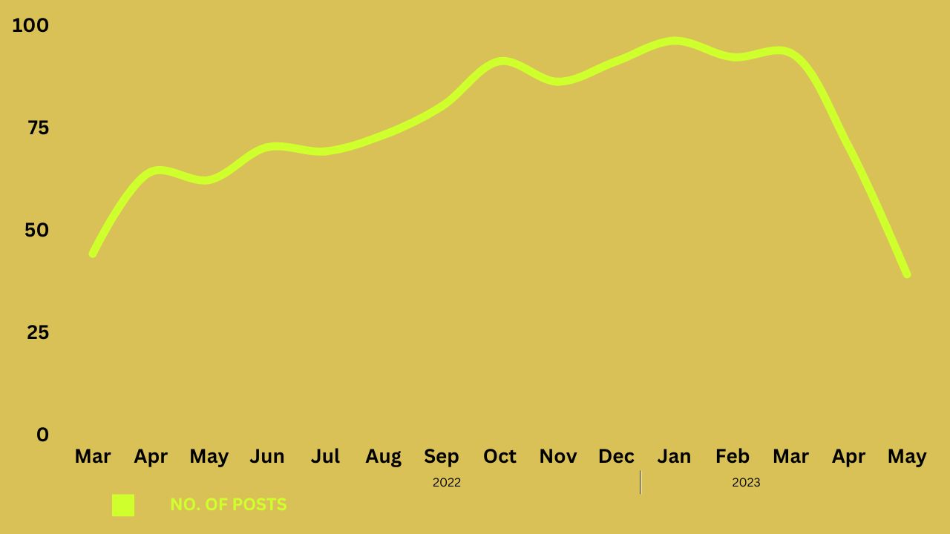

* **March 2022**: Ankur Warikoo started the year with 44 posts, setting the tone for his active presence on LinkedIn.
* **From April to June 2022**: The number of posts steadily increased, with Ankur Warikoo sharing 64, 62, and 70 posts respectively. This highlighted his commitment to regular content creation and engagement.
* **July to September 2022**: Ankur Warikoo maintained a consistent posting frequency during these months, with 69, 73, and 80 posts respectively. This showcased his dedication to providing valuable insights and updates to his LinkedIn audience.
* **October to December 2022**: These months saw a significant rise in Ankur Warikoo's posting activity, with 91 posts recorded for both October and December, and 86 posts in November. This demonstrated his sustained effort in sharing knowledge and building his professional network.
* **January 2023**: Ankur Warikoo's posting frequency reached its peak with an impressive 96 posts, reflecting his dedication and engagement with his LinkedIn audience. This month stood out as the most active period throughout the year.
* **February to May 2023**: Although there was a slight decrease in posting frequency compared to the previous month, Ankur Warikoo remained consistently active on LinkedIn, sharing 92, 93, 70, and 39 posts respectively. Despite the reduced number of posts in May 2023, his presence on the platform remained notable.

Ankur Warikoo's commitment to sharing valuable content and maintaining an active presence on LinkedIn has positioned him as a prominent influencer and thought leader in his industry. By consistently engaging with his audience, he has fostered professional connections and contributed to the knowledge-sharing community on the platform.

**Dissecting The Posts Of Ankur Warikoo- On What Days Does Ankur Likes To Post Mostly?**

I am delighted to present you the analysis of Ankur Warikoo’s posts in LinkedIn for over the past one year through carefully studying the data and making visualisations from it. We have acquired valuable insights from Ankur’s posting pattern over weeks and months. Let’s take a deep dive to understand the data and relevant insights from the numbers.

Firstly, we’re going to explore the Favourite and the 2nd Favourite Day of Ankur to post in a week over the course of the past one year.

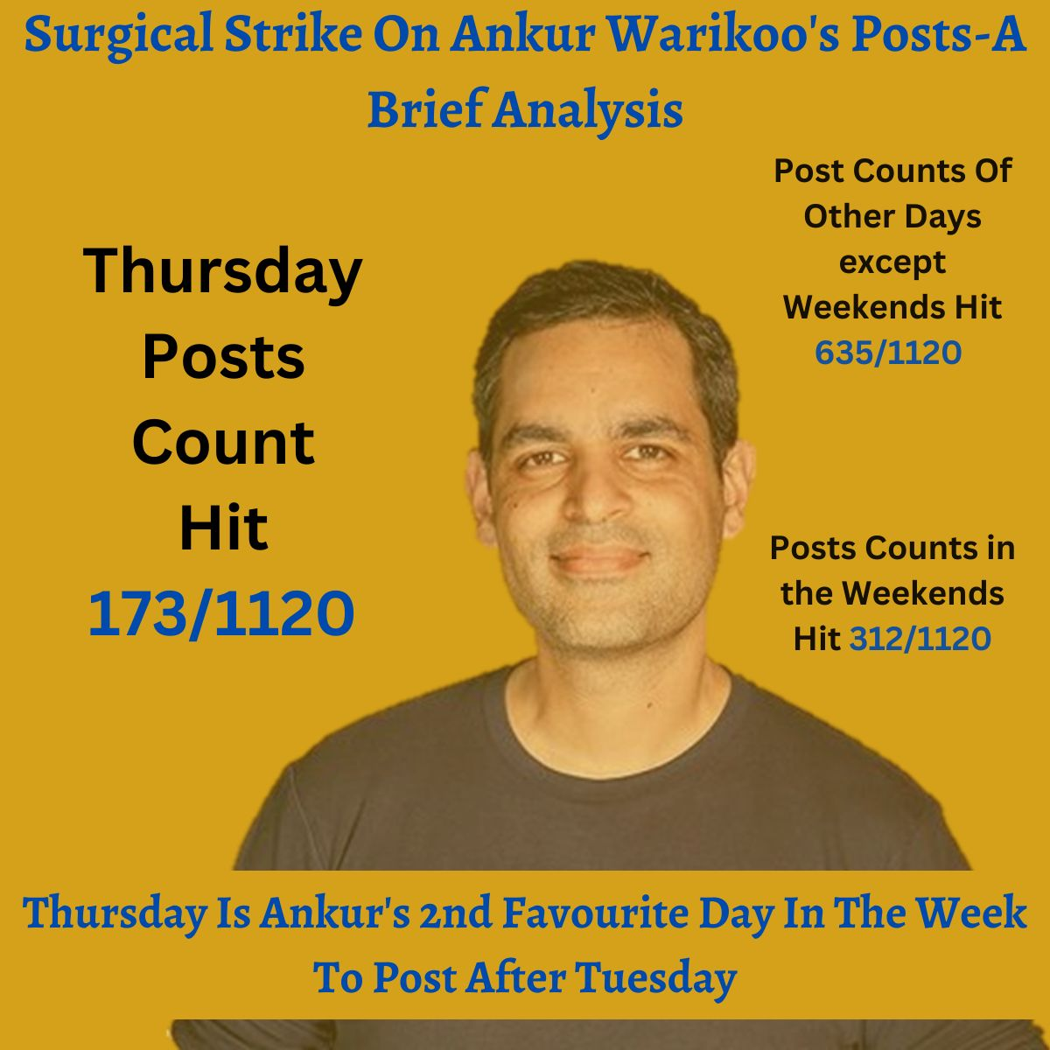

**Insight 1**: According to the data we processed, Ankur Warikoo's favourite day to post on LinkedIn is Tuesday. The data states that if Tuesday is Ankur's favourite day to post, then Thursday comes a close second. On these two days, he posts more than any other day in the week. Over the course of the past one year he posted 184 out of 1120 times on Tuesday. LinkedIn's algorithm might give preference to content posted on Tuesdays, leading to increased visibility and reach for Ankur's posts. The platform's algorithms are known to prioritize recent and popular content, so posting on a day with higher activity could potentially enhance the visibility of his posts.

While Tuesday is Ankur’s favourite day to post, Thursday comes a close second with post count hitting 173 out of 1120. Thursday might be a strategic choice for Ankur because it falls towards the end of the workweek. Posting on Thursday could allow his content to remain visible and relevant during the following workdays, potentially increasing its reach and engagement.

**The ‘Comments vs Reposts’ battle- What is the most preferred way of Ankur Warikoo to engage with his audience?**

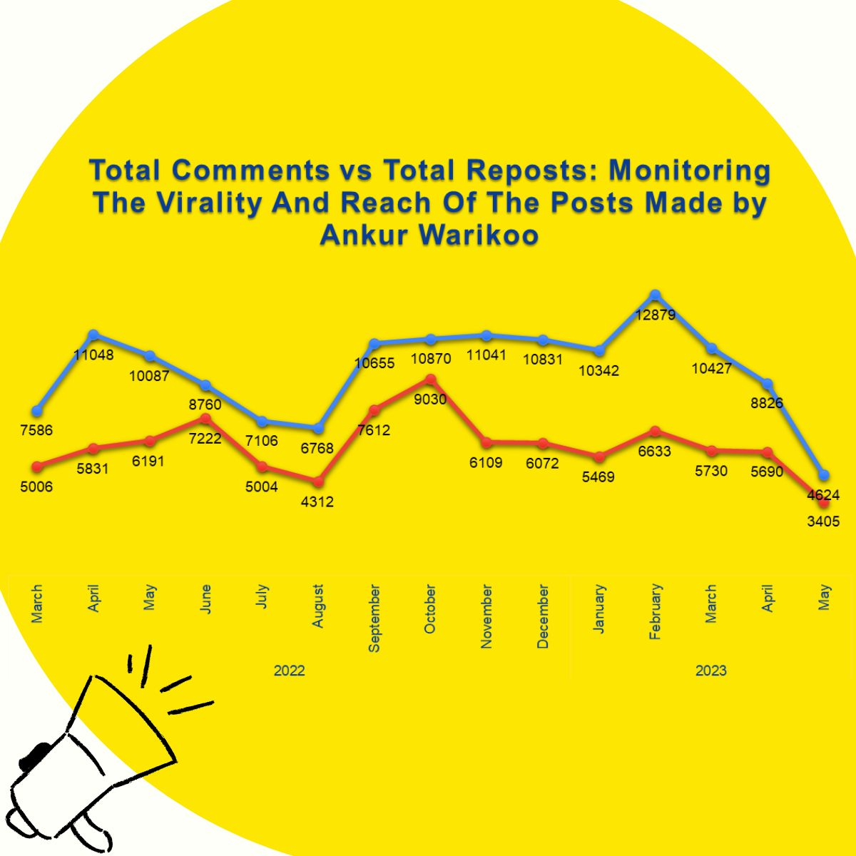

**Insight 2:** The data suggests that total number of comments over the past one year in Ankur’s post was 141850 while the total number of reposts were 89316. Therefore the 'Comment-to-Repost' Ratio is 1.59, it suggests that for every 1 repost received on the posts, there are approximately 1.59 comments. This ratio indicates a higher level of engagement through commenting compared to reposting. A higher ‘Comment-to-Repost’ ratio can be seen as a positive indicator because it suggests that Ankur's content is sparking conversations and discussions among his audience. It indicates that his posts are generating engagement in the form of comments, where people are actively sharing their thoughts, opinions, and interacting with the content.

Engagement through comments can be valuable as it provides an opportunity for deeper interactions, feedback, and discussions, which can contribute to building a community and fostering meaningful connections.

***Insightful Journey of Ankur Warikoo***

***Vaibhav Jhamb***

*I’m thrilled to present a comprehensive data analysis on Ankur Warikoo’s number of reposts over the year from March 2022 to May 2023. Through careful analysis and visualization of the data, we have gained valuable insights into Ankur's Insightful journey and how many people or followers find Ankur’s posts insightful.*

*Let's dive into the findings and stories behind the numbers.*

*Firstly, let's understand the number of Insights reactions to the overall 3,376 reposts he posted in a year.*

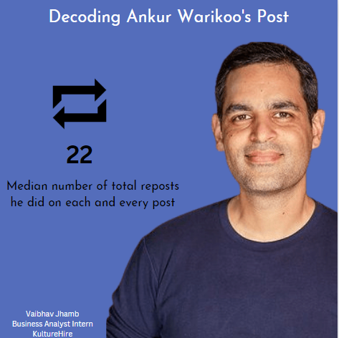

*1. The total number of medians reposts is 22.*

*2. The average number of reposts is 82.*

*3. The maximum number of reposts done is 2645.*

*4. The total number of reposts comes out to be 89316.*

***Trend number of Reposts***

*Moving on to the monthly analysis, we visualized the data using a Bar Chart. The chart provides a clear comparison of the reposts he did each month, allowing us to identify the months with the highest and lowest engagement. In 2022, July and August were the two lowest months whereas March and June were the two highest in terms of his insightful posts. In 2023, January and March were the lowest.* To put these numbers into context, let's delve into a theoretical story based on the data. Ankur Warikoo, a renowned influencer, has been capturing the attention and admiration of his audience. In 2022, Ankur's captivating content sparked an outpouring of Insight reactions, with his posts generating 894 total average interactions. In 2023, for the last 5 months, it’s 359. This speaks volumes about the resonance of his Insightful posts throughout the year.

I hope you found this data analysis on Ankur Warikoo's Insight reactions informative and insightful*.*

**A Closer Look at Consistency and Engagement**

**Introduction:**

This report presents an analysis of the trend of Monday posts by Ankur Warikoo on LinkedIn. The data covers the period from 2022 to 2023, providing insights into the engagement levels and identifying notable trends.

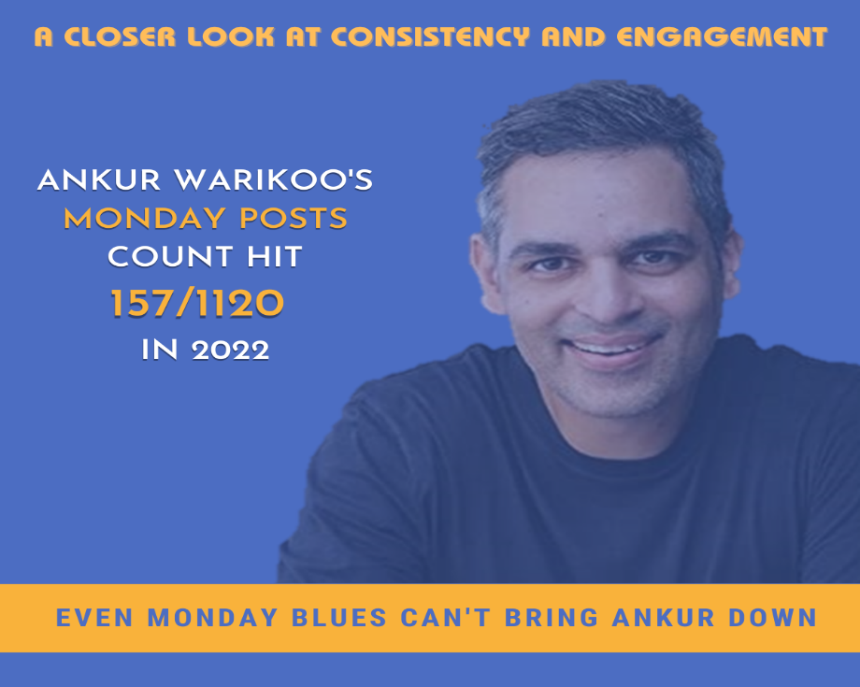

The highest number of Monday posts in a month over this period was 15, which occurred in February.

In 2022, the total number of Monday posts in a month varied throughout the year, with the lowest count being 6 in March.

The trend continued into 2023, where the Ankur warikoo received the highest number of Monday posts in a month in February, with 15 posts.

The total number of Monday posts in a month were more or less consistent over the whole time period.

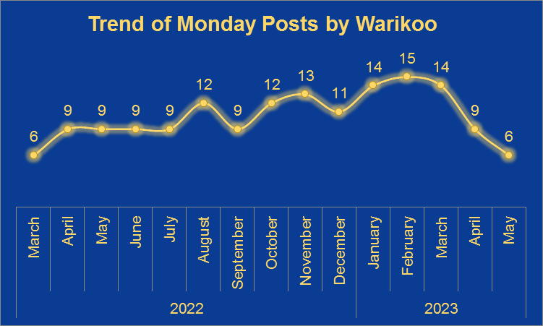

**Insights**:

* The trend shows that his posts on Mondays keep on increasing steadily with time, just tapering by the fag end of our observation time period.
* The Ankur warikoo’s Monday posts were constant during initial months but then spiked up as his popularity keeps on increasing.
* The lowest engagement was recorded in March with only 6 posts. This could indicate a relatively quieter period that didn't generate as much interest as he was not that famous back then.
* Ankur Warikoo’s Monday posts experienced notable peaks during January to March of 2023. With highest being in month of February with 15 posts.
* The increase in number of posts with the starting of year 2023 is due to the fact that his posts were generating more interest maybe due to the new year resolutions of people consuming valuable content.

**Conclusion:**

Based on the analysis of the provided data, the Ankur Warikoo's Monday posts on LinkedIn demonstrated more or less consistency with its frequency. Notable highlights include spike in number from October of 2022 with its peak being formed by the months of January to March of 2023. However, it is important to note that he is consistent with his posts, which is helping him to gain more popularity over time.

**How is Ankur Warikoo’s frequency of posts impacting his viewership reactions?**

Ankur Warikoo is a perfect example of a successful social media influencer in all aspects. His unique content and posting frequency have helped him engage the reactions of wider audiences across all social media platforms. Now, let's break down how his posting frequency on LinkedIn varies for his different types of content categories and how his followers are reacting to them.

The below data table shows the break-up of Ankur Warikoo’s Top 10 content categories based on if they are Scheduled or Random posts.

|  |  |  |
| --- | --- | --- |
| **Sum of Total Reactions** | **Frequency of Posts** |  |
| **Content Category** | **Random** | **Scheduled** |
| Text + Image | 31% | 69% |
| Text Only | 24% | 76% |
| Image Only | 22% | 78% |
| Carousel | 58% | 42% |
| Video | 59% | 41% |
| Others Reshare | 98% | 2% |
| Text+Video | 51% | 49% |
| Poll | 76% | 24% |
| Own Reshare | 93% | 7% |
| Image | 100% | 0% |
| Event | 100% | 0% |
| **Grand Total** | **37%** | **63%** |

We can see that on an average, his scheduled posts (63%) are reacted to way higher than his random posts (37%). This shows a tremendous strategy by Ankur and his team to keep engaging his followers daily through scheduled posts. Also, we can derive the following insights from the data table:

* When his content type consists of Text, Image, or both of them together it is predominantly a scheduled post at a particular time of the day and the audience is reacting very positively towards it.
* However, when the content consists of videos or a carousel, we can see that the random posts are more and his followers are liking them.
* When Ankur is sharing other’s posts, the random posts have much higher reactions than the scheduled posts.
* When Ankur is resharing his own posts, the random posts have much higher reactions (93%) than the scheduled posts (7%).
* Also, we can see that when there is an event, it is 100% a random post and not a scheduled one.

The given data table can also be depicted as the graph given below which gives a very good idea behind the different content creation and their types of posting based on weekend/weekday and their viewership impact.

* The scheduled posts for Text, Image, or both together planned on weekends are higher which is a clever strategy to engage more audiences at a scheduled time and capture their reactions.
* The video-related posts are also posted at random on weekends to maximize the impact as more people will have the time to view the complete post and react to it.
* The reactions to Carousel show 58% for random posts and 42% for scheduled posts. However, from the graph we can see that the Carousel posting frequency are spread through the weekends/weekdays at a comparable rate as random/scheduled posts. This shows a completely different strategy employed to gain the maximum reactions from Ankur’s followers for Carousel posts.

**CONCLUSION**:

The difference between a successful influencer and a struggling one to make a mark depends on the type of content posted coupled with when the content is posted. The collected sample data corroborates the fact that along with the what and how to post, if the when to post is also clearly strategized, it can garner the attention of even the silent audience and gain their reactions. Each content category requires a different technique so that the audience can resonate with the same. So, we can conclude that Ankur and his team are leveraging the LinkedIn platform and maximizing their follower's reactions with a well-thought-out plan for their posts.

**Ankur - The man with a plan !!!**

**Scheduling posts in LinkedIn**

LinkedIn has this unique feature to post content on a Scheduled Time by its users.

The user can schedule posts between an hour and 3 months in advance. After you schedule the post, you can't edit the content of the post, but you can delete or reschedule the post.

**Insights on Ankur’s Scheduled posts and Random posts**

Based on the data collected, Ankur posts his content mostly using the Scheduled option available in LinkedIn. His other type of posting is on random timings.

Out of 1120 posts by Ankur last year, 45% are Random posts while 55% are Scheduled posts.

**Monthly trend of Ankur’s posts**

In the year 2022, his random posts were more compared to 2023. Especially during the month of October 2022, his random posts hit the peak only to slowly decline in the later months.

Meanwhile his Scheduled posts started to gradually grow from October 2022 onwards and hit its highest in January and March 2023 of 63 posts.

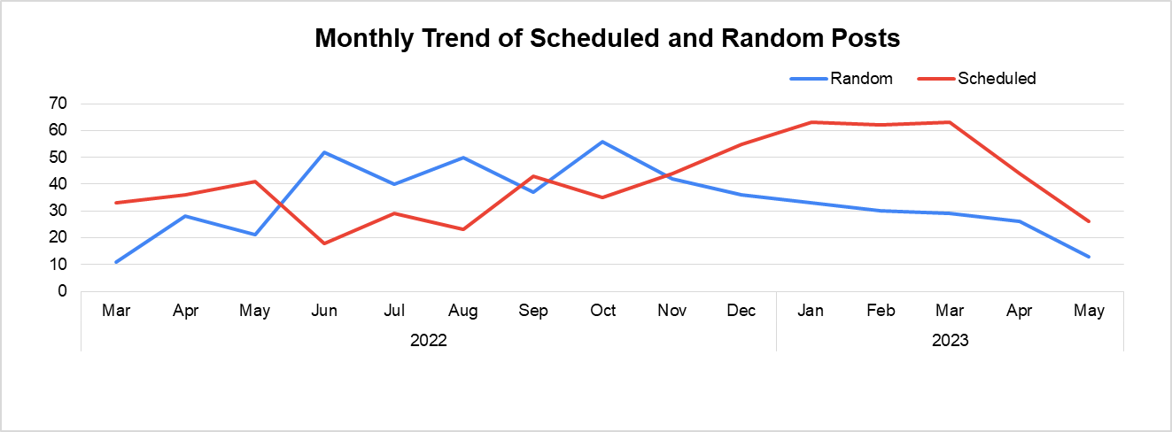

**Weekends Vs Weekdays**

On a different perspective, Ankur usually schedules his posts mostly on Weekends compared to his random ones. Don’t you find it fascinating that 72% of his weekend posts are Scheduled?

Ankur is well scheduled on his weekends !!

**Posting pattern based on Content Categories**

Based on the type of content Ankur posts, Text+ Image and Text Only contents are the predominant scheduled posts. While Polls, Carousel and Image posts are mostly random and instant contents. Looks like he pens down his random thoughts to schedule which is popular among his users!!!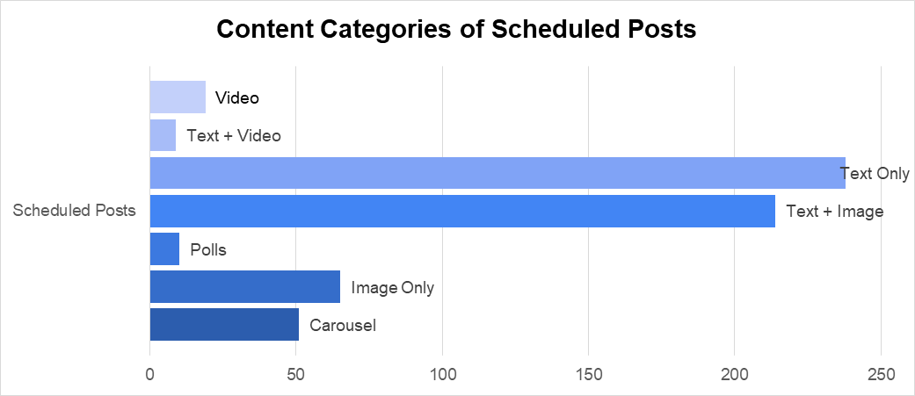

**User Engagement**

Clearly his Scheduled posts are the most successful ones in terms of user engagement. The user engagement includes Likes, Comments, Reposts and Reactions like Funny,Love, Support, Celebration.

The scheduled posts get an unprecedented wave of engagement of 62% out of 1120 posts among his users which is a profound number.

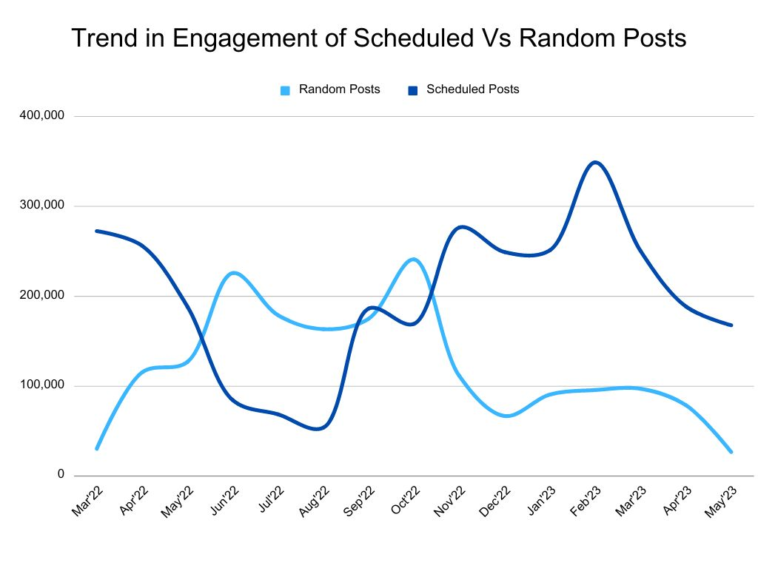

Ankur’s success trend in user engagement hits the peak in February 2023 on his Scheduled posts while it is October 2022 for Random posts.

Ankur Warikoo is mostly present in his media content while he is actively seen in Random posts rather than the Scheduled posts. Ankur is absent in whooping 63% of his random posts while he is present in 37% of his scheduled posts. He brands himself by posting his images or videos in LinkedIn and it is nearly 40% in his Scheduled posts.

**Ankur warikoo’s LinkedIn post that is focused on the weekdays vs weekend**

we found that Ankur has posted a total of 808 pots in the weekdays and 312 posts in the weekends with total of 1120 posts.

Ankur Warikoo's posts received a total of 2,997,045 reactions on weekdays and 1,607,247 reactions on weekends, with a grand total of 4,604,292 reactions overall. On an average weekdays has got total of 3710 reactions and on weekends total of 5152 reactions. The overall average number of reactions per post was 4,110. When it comes to the comments for the posts there was a total of 141850 comments given for the total posts with 1054154 comments on weekdays and 37696 comments on the weekends.

When we broke down the reactions by month and year, we discovered that in 2022, the reactions were higher on weekdays compared to weekends. However, in 2023, the trend shifted, and the reactions on weekends surpassed those on weekdays.

Analysing the data further, we observed a consistent pattern throughout 2022, where weekdays had a higher number of posts compared to weekends. However, in 2023, the trend shifted, and the number of posts decreased for both weekdays and weekends. It is worth noting that January had the highest number of posts on weekdays (71) and weekends (25) in 2023.

The analysis shows that on weekdays, Ankur Warikoo shared a total of 808 posts, while on weekends, he shared 312posts, resulting in a grand total of 1,120 posts. The types of posts shared include Carousel (112), Event (1), Image (1), Image Only (88), Link (2), Others Reshare (101), Own Reshare (15), Poll (63), Text + Image (321), Text Only (339), Text+Video (21), and Video (55). Notably, Text Only and Text + Image were the most frequently shared types of posts on both weekdays and weekends. This analysis provides insights into the distribution of posts types and helps identify the content preferences and strategies employed by Ankur Warikoo in his social media posts.

**Conclusion:**

In conclusion, the analysis of Ankur Warikoo's LinkedIn posts provides valuable insights into his engagement patterns, content distribution, and link sharing behaviour. The data reveals that Ankur Warikoo's posts generally received higher reactions on weekdays compared to weekends, although there was a shift in 2023 where weekends surpassed weekdays in terms of reactions. The average number of reactions per post was higher on weekends, indicating potentially higher audience engagement during that time. Additionally, the analysis containing posts showed variations in the count and types of posts shared between weekdays and weekends. Text Only and Text + Image were the most common types of posts shared. These findings highlight the importance of understanding audience behaviour, optimizing content strategies, and adapting to changing engagement patterns to effectively communicate and engage with the audience on LinkedIn.

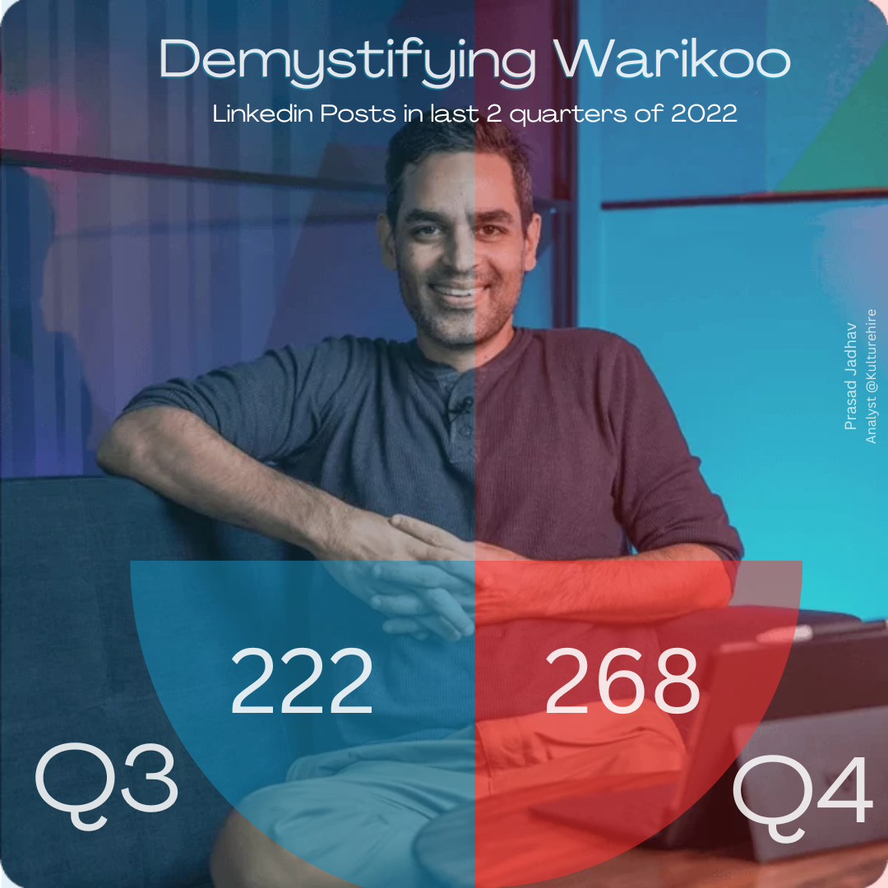**Analysis of Ankur’s posts in the last quarters of 2022**

Ankur Warikoo is always consistent in posting value-added content on LinkedIn and has amassed a massive 2 million followers on LinkedIn. He has an average of 3 posts every day on LinkedIn.

As we can see the no. of posts increased in Q4 with a nearly 20% increase from the previous quarter.

The reason behind this is Ankur’s posts receive the most engagement at the end of year hence the no. of posts is greater in Q4.

If we further segregate Q4, the no. of posts is evenly distributed with 90,86 and 90 posts in the months of October, November and December respectively.

In Q3 the total of reactions on his posts is 783637 and this number soared to 1,059,292 in Q4.

**A deep-dive into one of the factor how he gets most of the number of reactions on his LinkedIn posts**

**Introduction:**

This section will give you a brief about how Ankur figured out the suitabe timing to post something on LinkedIn and getting high number of reactions on his posts. This analysis covers the period of Mar’ 22 and May’23.

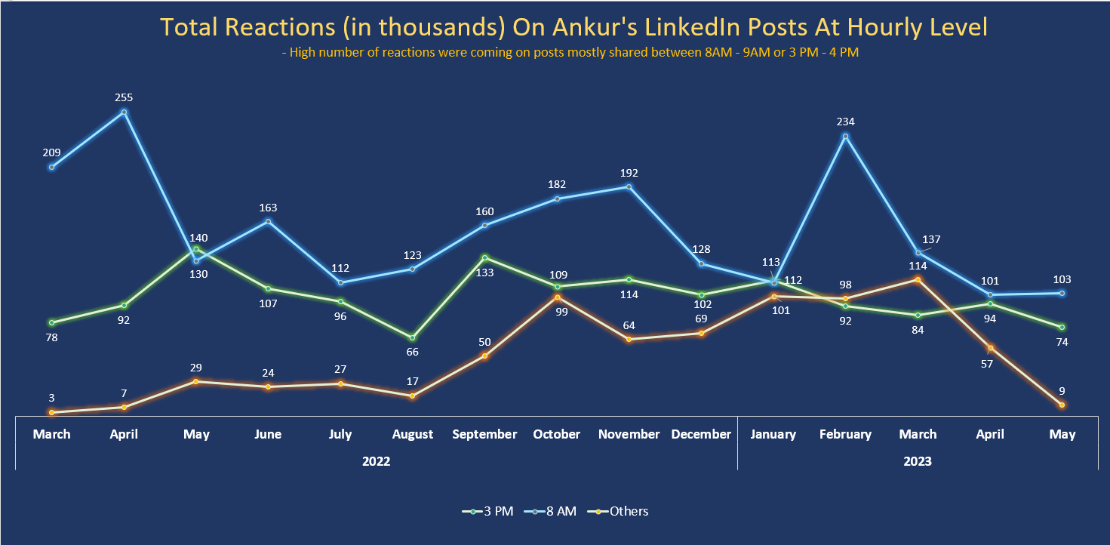

**Insights:**

* There are three buckets of time created which are 8 AM – 9AM, 3 PM – 4PM and ‘Others’ which include rest of the hours
* The above grouping was done after witnessing a pattern that high number of post reactions were coming when Ankur is posting between the timings 8 AM – 9AM and 3 PM – 4PM which can be clearly seen in chart
* The peaks for post reactions during the time period of 8 AM – 9 AM was during months of Apr’ 22 and Feb’ 23
* The peaks for post reactions during the time period of 3 PM – 4 PM was during months of May’ 22 and Sep’ 22
* Although, the total number of post reactions for the time period of 8 AM and 3 PM are not in a particular range every month but the trend continue to be in their favour as the total number of post reactions are coming during that duration only

**Conclusion**

Ankur Wariko knows the drill and he has cracked the way about when to share a post on LinkendIn to get some higher reach. This can be seen from the fact that in last one year, he has received high number of post reactions when he has shared his post majorly during the time period between 8 AM – 9 AM, and 3 PM – 4 PM.

**A Closer Look at Post Likes and Engagement**

**Introduction:**

This report presents an analysis of the trend of Liked posts by Ankur Warikoo on LinkedIn. The data covers the period from 2022 to 2023, providing insights into the total number of Likes throughout.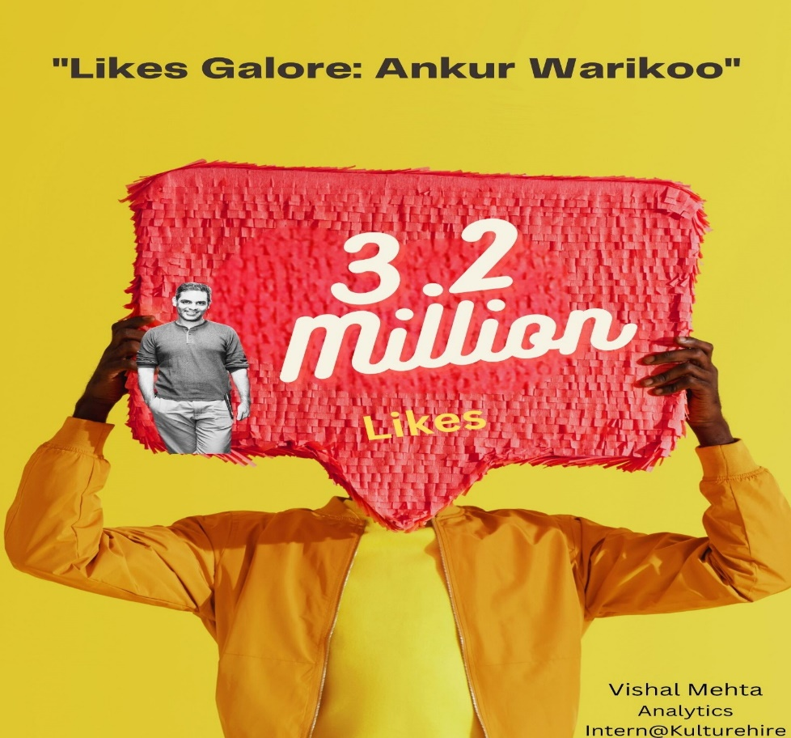

Analyzing the total number of likes on a LinkedIn post from the period of 2022-2023 requires understanding the dynamics of LinkedIn engagement and how it can vary over time. While I don't have access to specific data for that period, I can provide some insights based on general trends and knowledge up until May 2023

1. Content Quality and Relevance: The quality and relevance of the content shared on LinkedIn posts significantly impact the number of likes they receive. Engaging, informative, and well-presented posts tend to attract more likes. Posts that offer unique insights, valuable advice, or address trending topics have a higher likelihood of receiving a greater number of likes.
2. Reach and Visibility: The visibility of a post plays a crucial role in the number of likes it accumulates. LinkedIn employs an algorithm that determines the reach of each post, based on factors such as the user's network, post engagement, and relevance to the audience. If a post is displayed to a wider audience and resonates with them, it is likely to receive more likes.
3. Timing and Frequency: The timing of a post can influence its performance in terms of likes. Posting at times when your target audience is more active and engaged on the platform can lead to increased visibility and subsequently more likes. Consistency in posting is also important, as regular activity helps maintain an engaged audience and increases the likelihood of receiving likes.
4. User Engagement: Encouraging engagement from your network can contribute to receiving more likes. Engaging with other users' content, responding to comments on your posts, and actively participating in relevant discussions on LinkedIn can boost your visibility and attract more likes to your own posts.
5. Network Size and Target Audience: The size and composition of your LinkedIn network also affect the number of likes you receive. Having a larger network increases the potential reach of your posts, while having a well-defined target audience ensures that your content reaches people who are more likely to engage with it and provide likes.
6. Virality and Influencers: Occasionally, certain posts may go viral or receive attention from LinkedIn influencers. Such exposure can lead to an influx of likes and significantly impact the overall numbers. However, the virality of a post is unpredictable and depends on various factors, including the content itself, timing, and the reactions of influential users.

It's important to note that LinkedIn's algorithms and user behavior can evolve over time, potentially impacting the dynamics of likes on posts. To obtain more accurate insights about the total number of likes on LinkedIn posts from 2022-2023, it would be necessary to refer to specific data and analytics from that period.

To analyze the total engagement in LinkedIn posts from the years 2022-2023, specifically focusing on the difference between scheduled and random posts made by Ankur Warikoo, we'll consider the general principles of post scheduling and random posting on LinkedIn. Please note that the following insights are based on general knowledge up until May 2023

**Scheduled Posts:**

* + Consistency and Timing: Scheduling LinkedIn posts allows for consistency in content delivery. Regularly posting at optimal times when the target audience is active can increase the visibility of posts, resulting in higher engagement. By adhering to a predefined schedule, Ankur Warikoo can potentially attract a consistent following and generate more engagement over time.
  + Planning and Optimization: Scheduling posts in advance provides an opportunity to plan and optimize content. Ankur Warikoo can dedicate time to crafting well-thought-out posts, ensuring they are relevant, valuable, and appealing to his target audience. This level of planning can potentially increase engagement by offering high-quality content consistently.

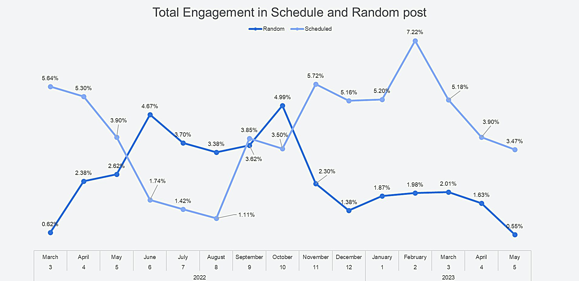

**Random Posts:**

* + Spontaneity and Authenticity: Random posts can introduce an element of spontaneity and authenticity. Sharing impromptu thoughts, experiences, or insights in real-time can resonate with the audience on a personal level, leading to higher engagement. Ankur Warikoo might leverage random posting to showcase his genuine personality, provide immediate responses to current events, or share unique moments. This approach can foster a deeper connection with the audience and elicit more engagement.
  + Timeliness and Trend Relevance: Random posting allows for timely responses to trending topics or industry-specific discussions. By seizing the moment and posting relevant content promptly, Ankur Warikoo can tap into ongoing conversations and capture the attention of his target audience. This can potentially result in higher engagement, as users are more likely to engage with posts related to current trends or discussions.

It's important to note that the success of scheduled and random posts in terms of engagement can vary based on factors such as content quality, relevance, timing, and the overall engagement strategy employed by Ankur Warikoo.

Conclusion:

In the years 2022-2023, Ankur Warikoo's LinkedIn posts experienced a significant total engagement of 32 million likes. This impressive engagement can be attributed to a combination of scheduled and random posts. The scheduled posts, with their consistent delivery and optimized timing, garnered a substantial portion of the likes, while the random posts, infused with spontaneity and authenticity, captured attention and generated additional engagement. By utilizing both strategies, Ankur Warikoo effectively maximized his reach, connected with his audience, and achieved remarkable engagement on LinkedIn.